 Cognizant Technology Solutions

Sudip Kumar Kundu 2320440

AWS Project on Customer Segmentation

* **Requirement I: Import customer data into Amazon Redshift.**

Redshift is a massively parallel column-oriented database deployed on AWS platform, that makes it simple and cost effective to analysis all data across Data warehouse.

The process of loading Data into the Amazon Redshift from S3 are shown below.

**4**

Create IAM Permission

Create Redshift Cluster

**3**

**2**

**1**

Load The Data.

Create S3 Bucket

**1.Creating Bucket:**

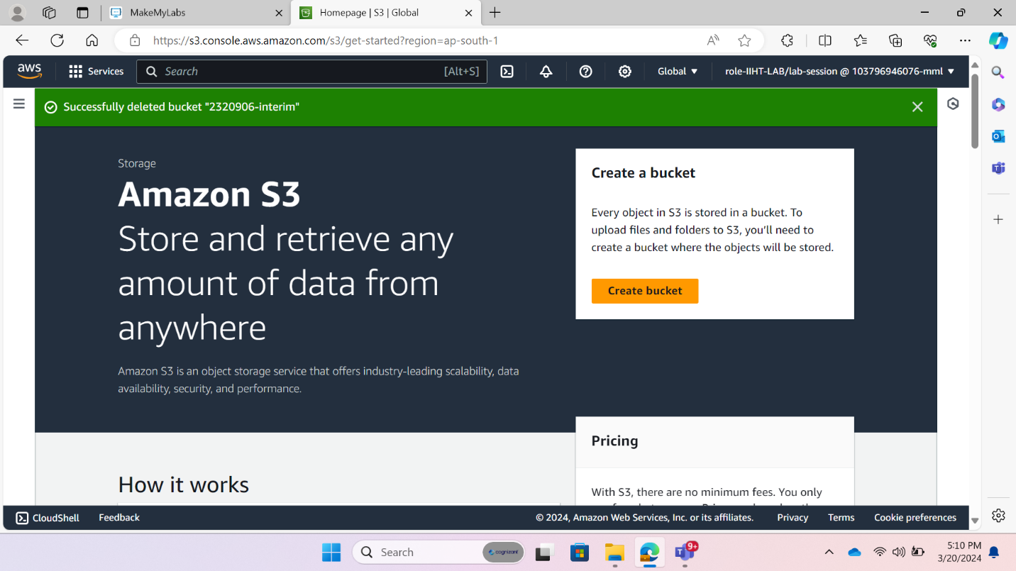The first stapes of Load Data from S3 To RedShift is Creating a Bucket. For that first we open the S3 consol. The Below fig1 is shown the consol of S3.

Fig:1 S3 Consol

To create Bucket, we click on “Create Bucket”. Then new window will open that shown in below fig:2.

Here we provided AWS region name i.e., Asia pacific (Mumbai) ap-south-1.

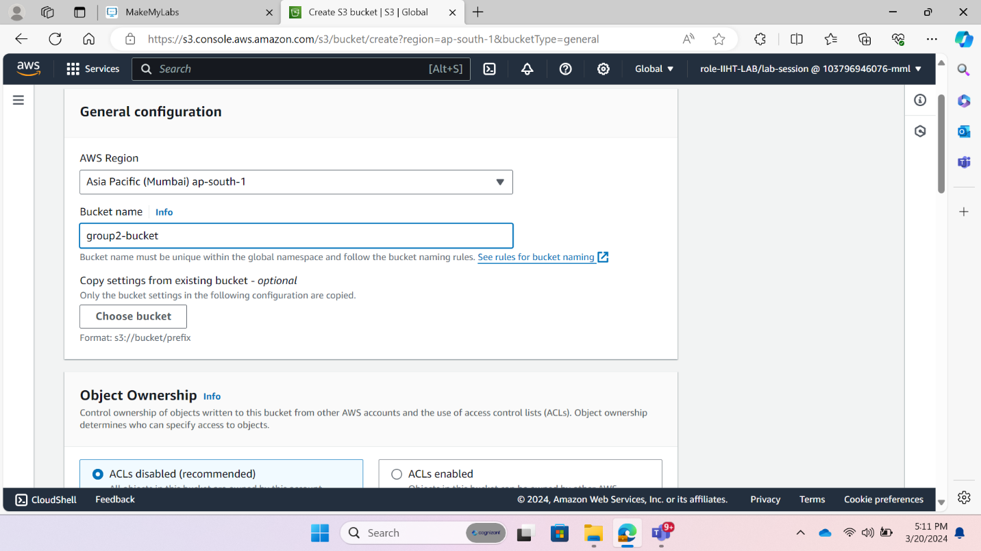 And then Bucket name.

Fig:2 S3 Consol-2

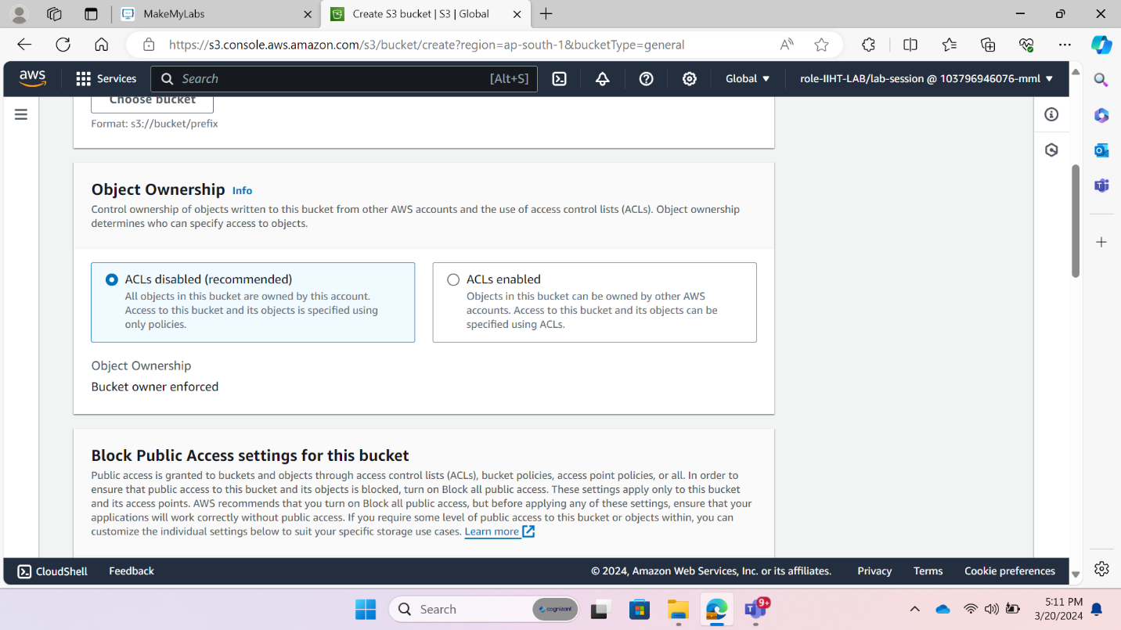Then we chose the object Ownership that determines who can access the object. For us we are going with ACLs disabled.

Fig:3 S3 Consol-3

Then we allowed the public access and Bucket versioning i.e. it can keep multiple variants of object in the same bucket.

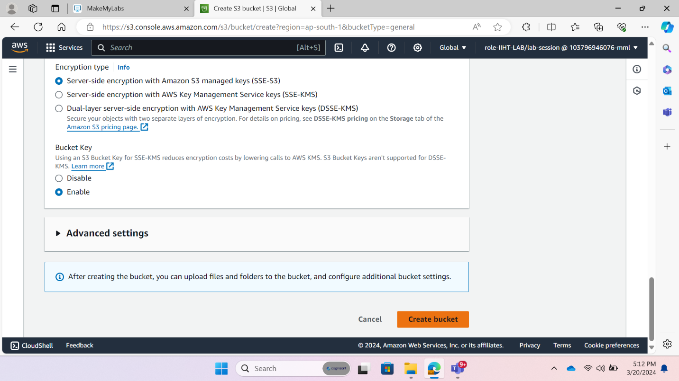At last, Bucket is created using the “Create Bucket Option

Fig:4 S3 Consol-4

**2.** **Create IAM permission:** In AWS IAM stands for Identity Access Management. It is used to securely access the AWS services and resources. It helps to enhance the security by ensuring that only authorized individuals or system can interact with our AWS.

Here we created a role for S3 as well as Redshift.

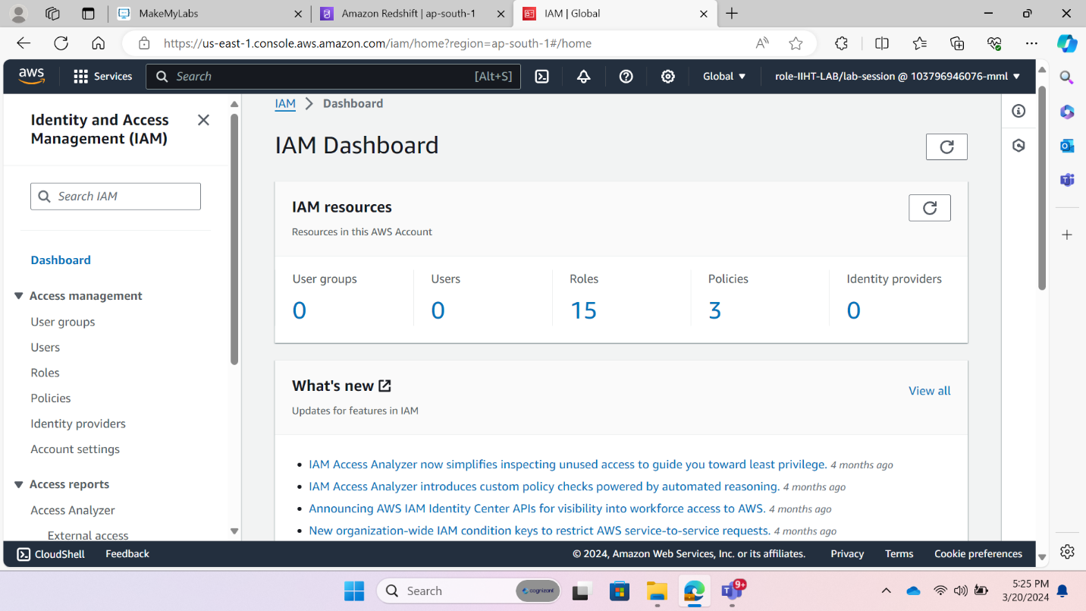The IAM dashboard is shown below fig 5.

Fig:5 IAM Dashboard

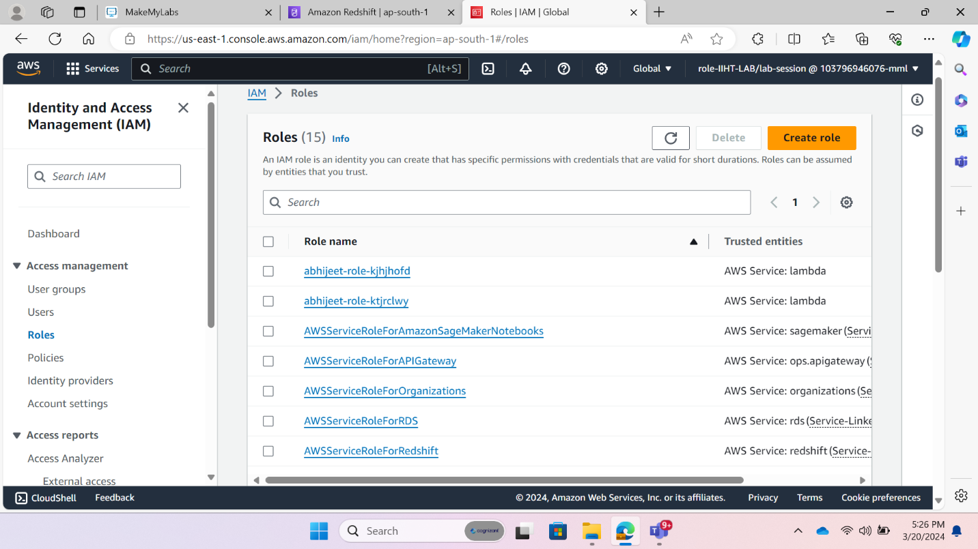To create a role, we clicked on “role”. And then clicked on “create role”.

Fig:6 IAM Dashboard-2

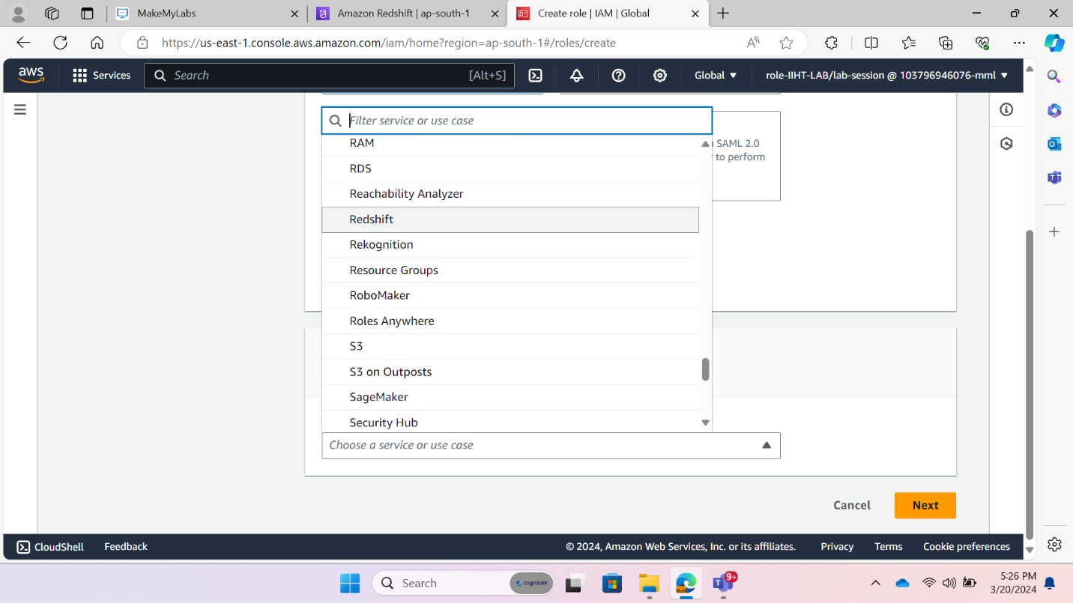Then In Use case section we chose “Redshift” service. That shown in below fig 7

Fig:7 IAM Dashboard-3

Then we chose the “Redshift Customizable” for specified services. That is shown in fig 8.

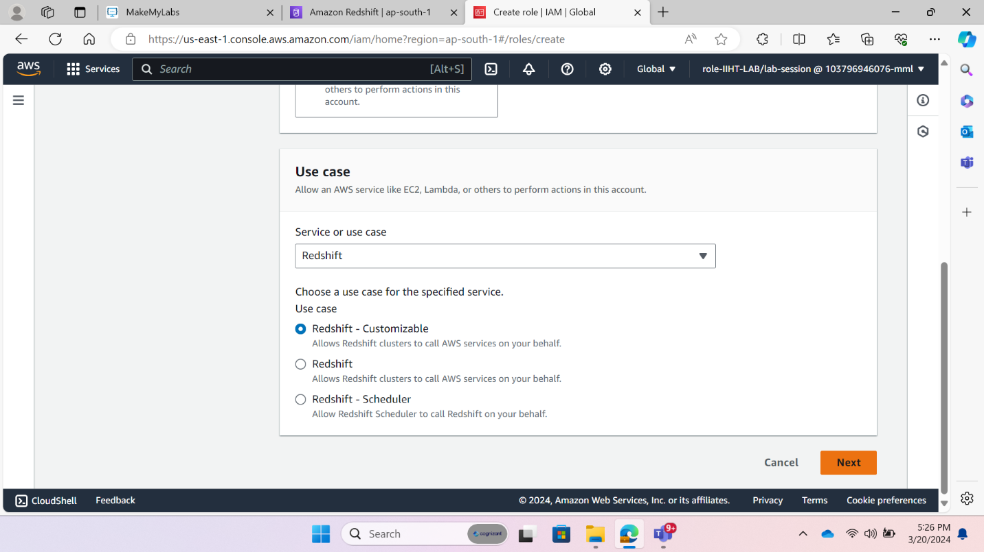

Fig:8 IAM Dashboard-4

Then we selected permission like “S3 Full Access”, Shown in fig 9.

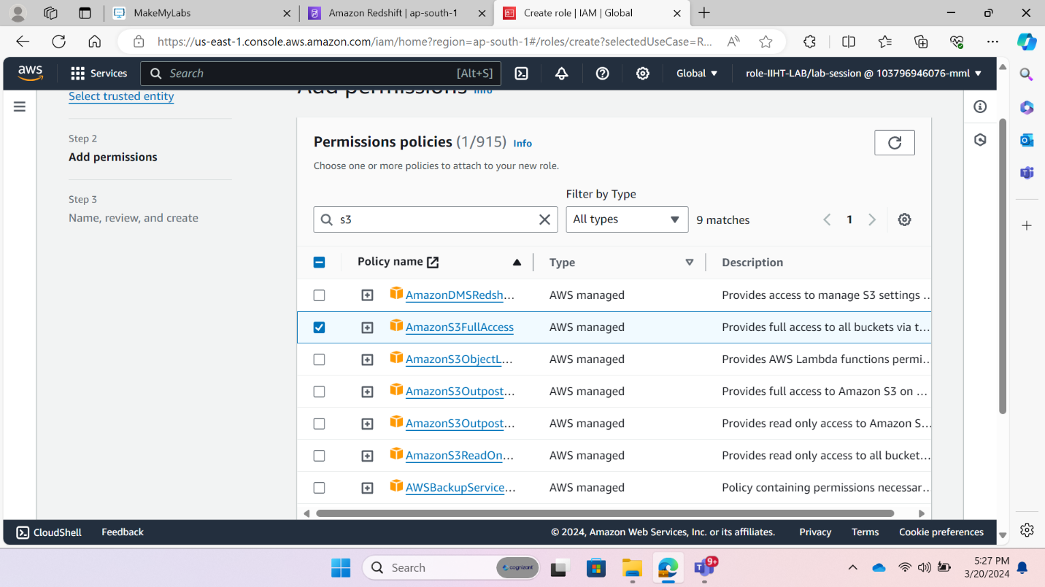 Then we provided the Role details like Role name and Its description.

Fig:9 IAM Dashboard-5

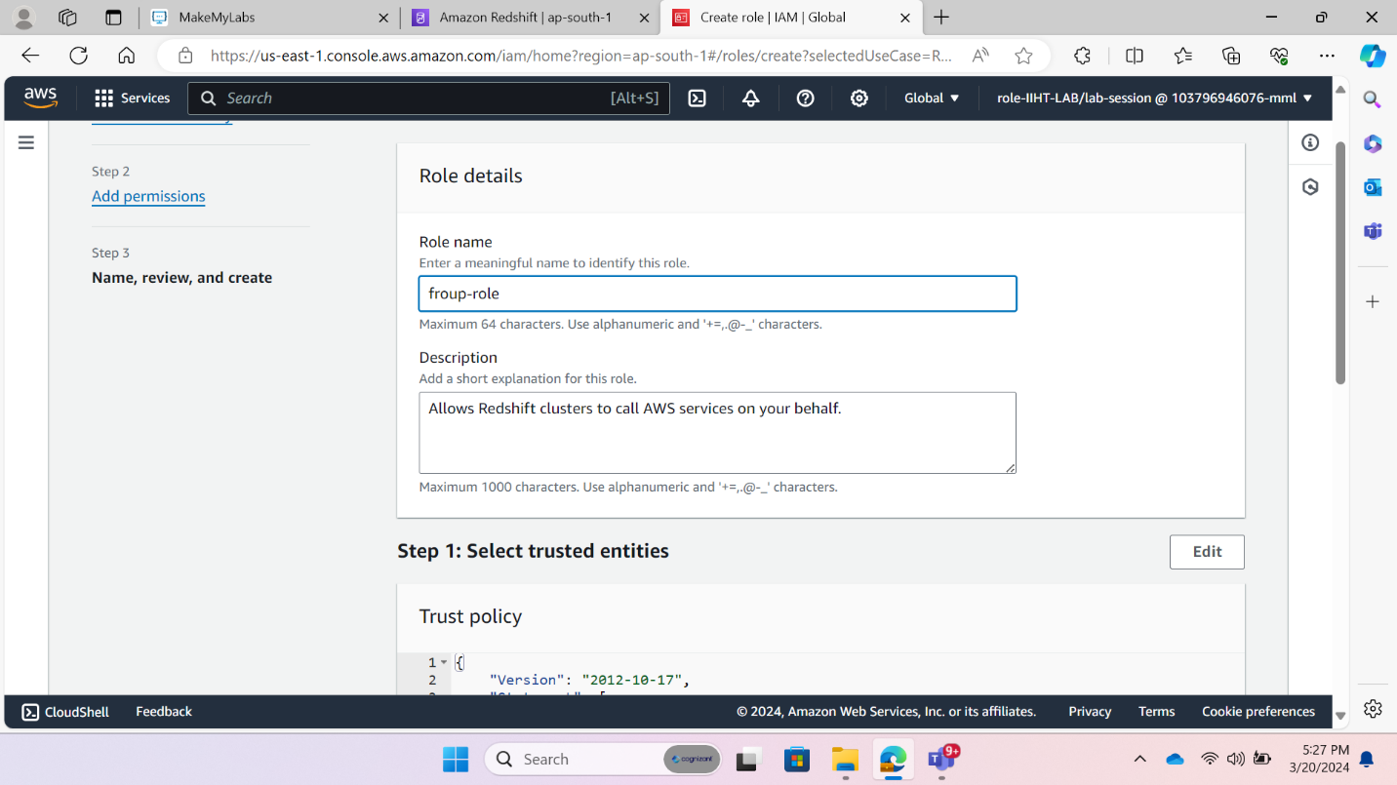

Fig:10 IAM Dashboard-6

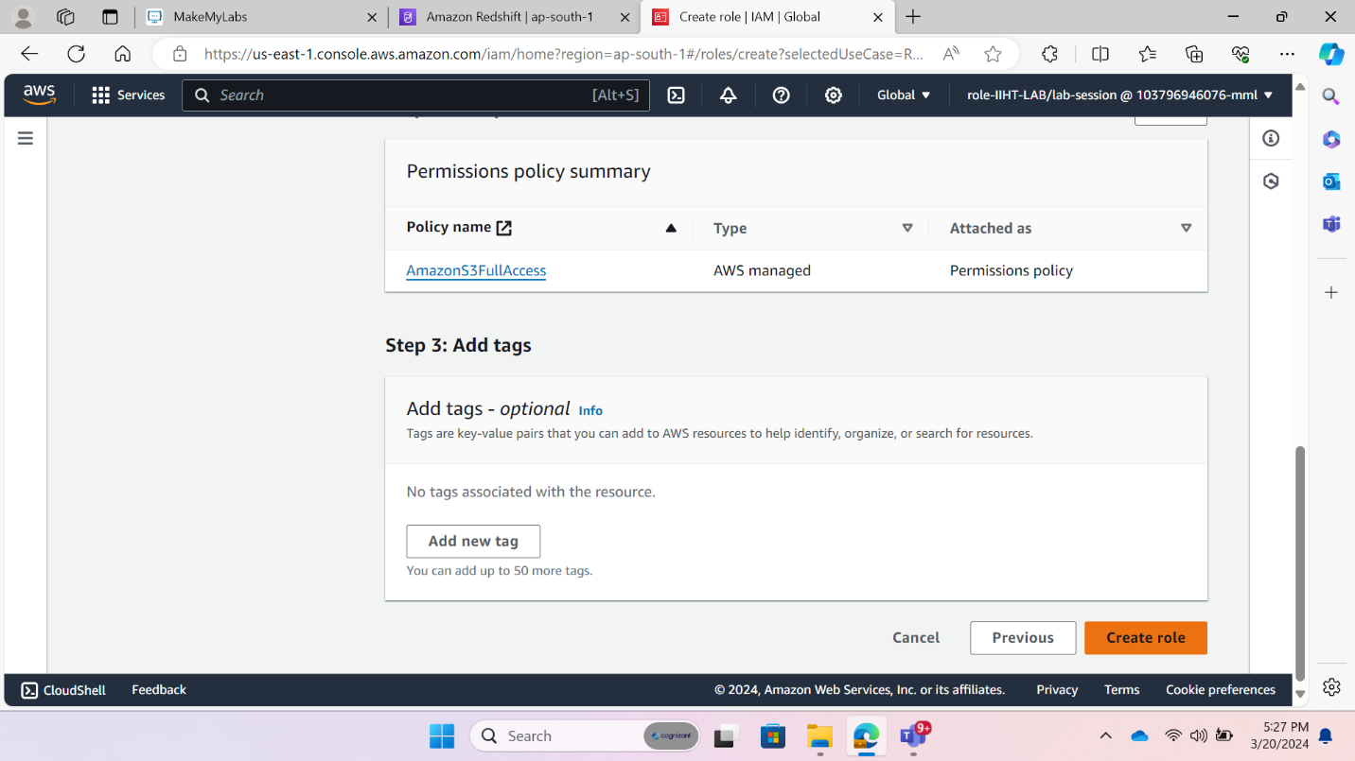After performing this step, we created role by clicking on “Create role.”

Fig:11 IAM Dashboard-7

**3.Create Redshift Cluster:** Redshift is a massively parallel, column-oriented database deployed on AWS platform that makes it simple and cost effective to analyses all data across data warehouses.

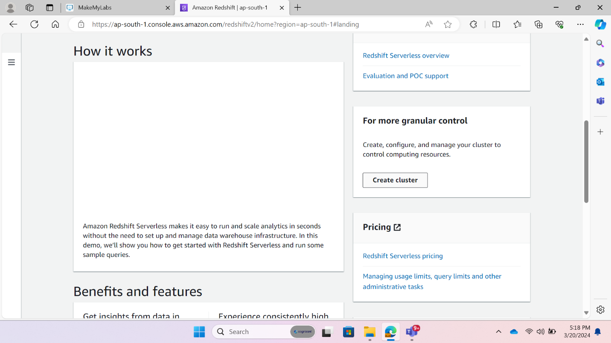The steps of creating Redshift we opened redshift consol. The consol is shown below fig 12.

Fig:12 Redshift consol

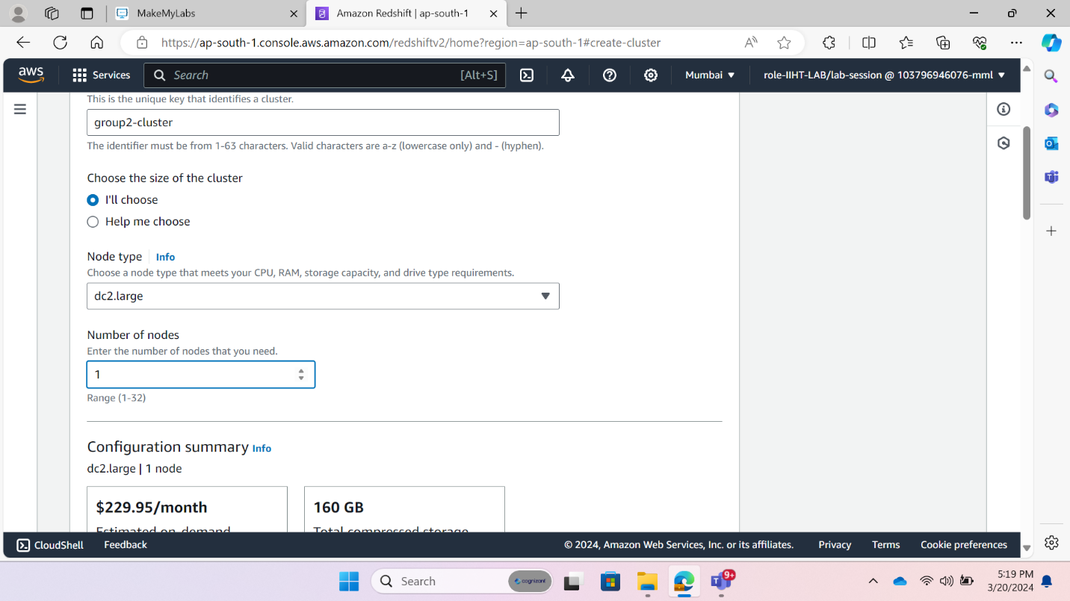Then “create cluster” for creating cluster. After that we provided some necessary information for creating cluster like cluster identifier “group2-cluster”, node type. Here we used “dc2.large” node that shown in fig 13.

Fig:13 Redshift-cluster-creation1

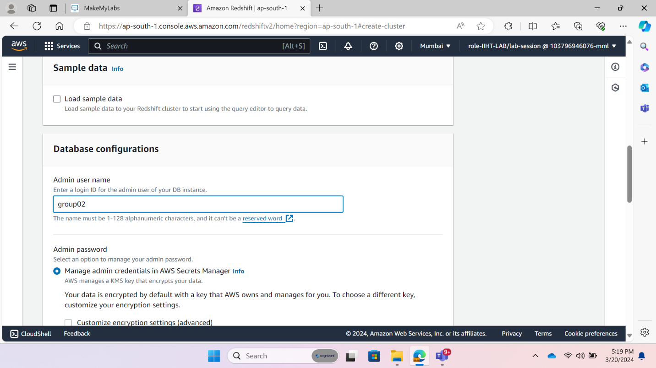Then we provided the admin username shown in fig 14.

Fig:14 Redshift-cluster-admin name

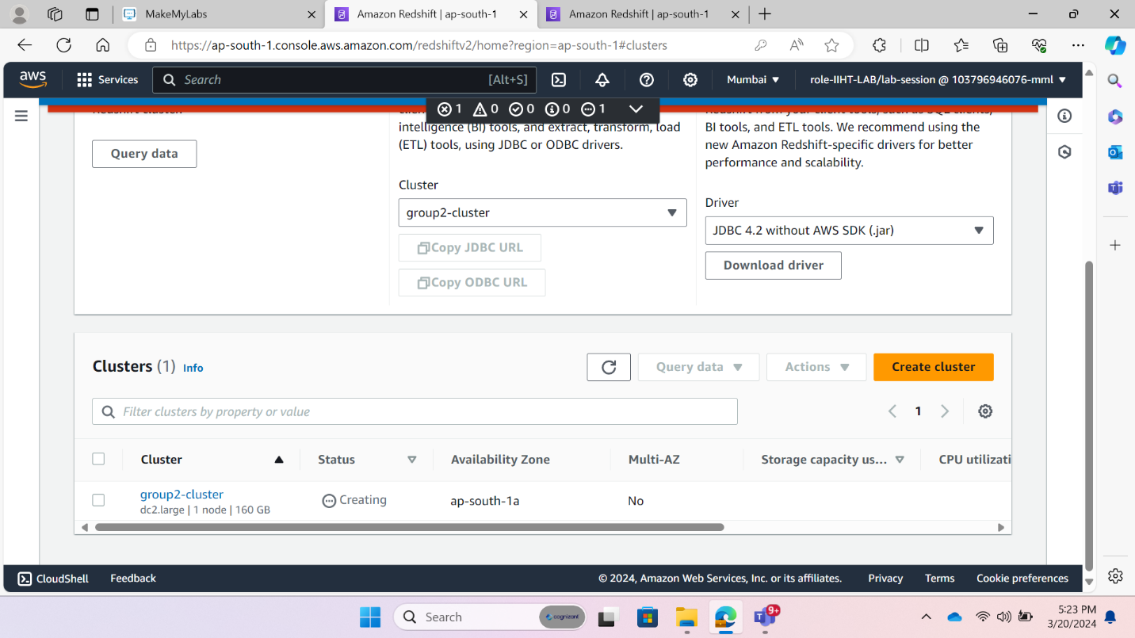After performing all necessary task, we created a cluster that is shown in below fig 15.

Fig:15 redshift Dashboard

Then we attached IAM role with Redshift cluster. For that we clicked on our cluster. Then the cluster property. and then associate IAM Role to attached Role.

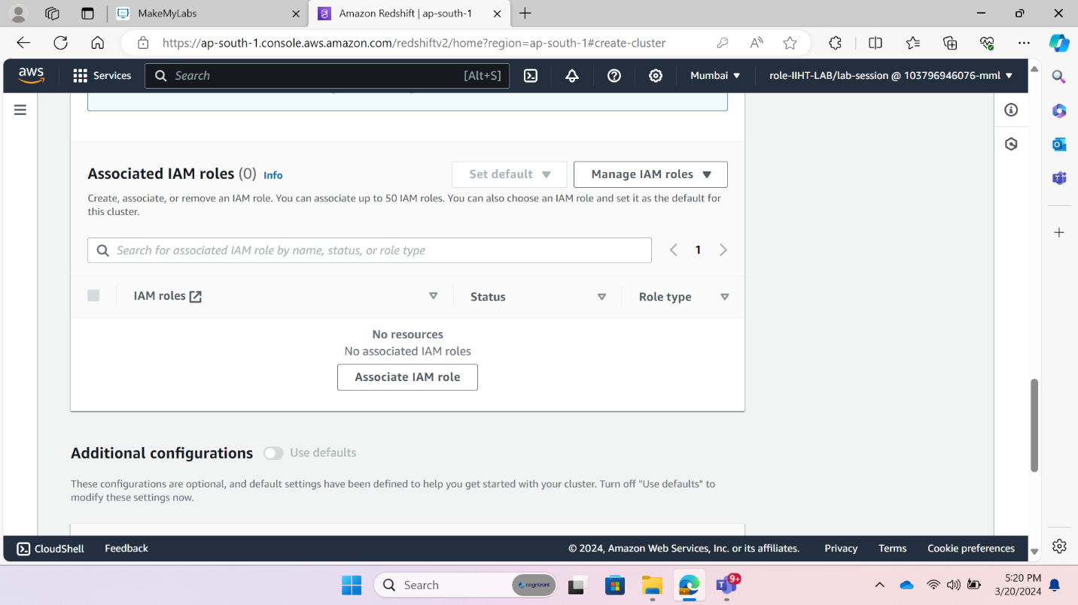

Fig:16 redshift IAM role Attached

After that we selected IAM role that was already created.

Fig:17 redshift Associate IAM role

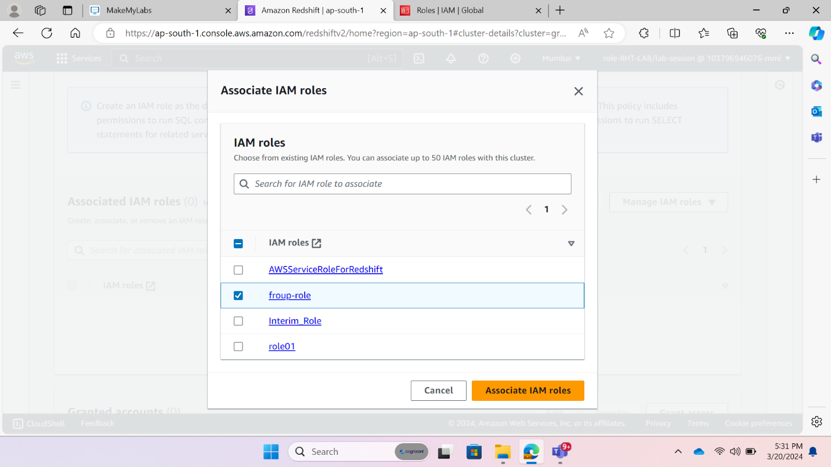

**4.Load The Data:** Data is load in two stapes in first steps we loaded data from our local machine to S3 bucket and then S3 to Redshift cluster.

**Data load Local machine to S3 Bucket**

First, we clicked on our S3 bucket. Then we found the file upload option in objects section.

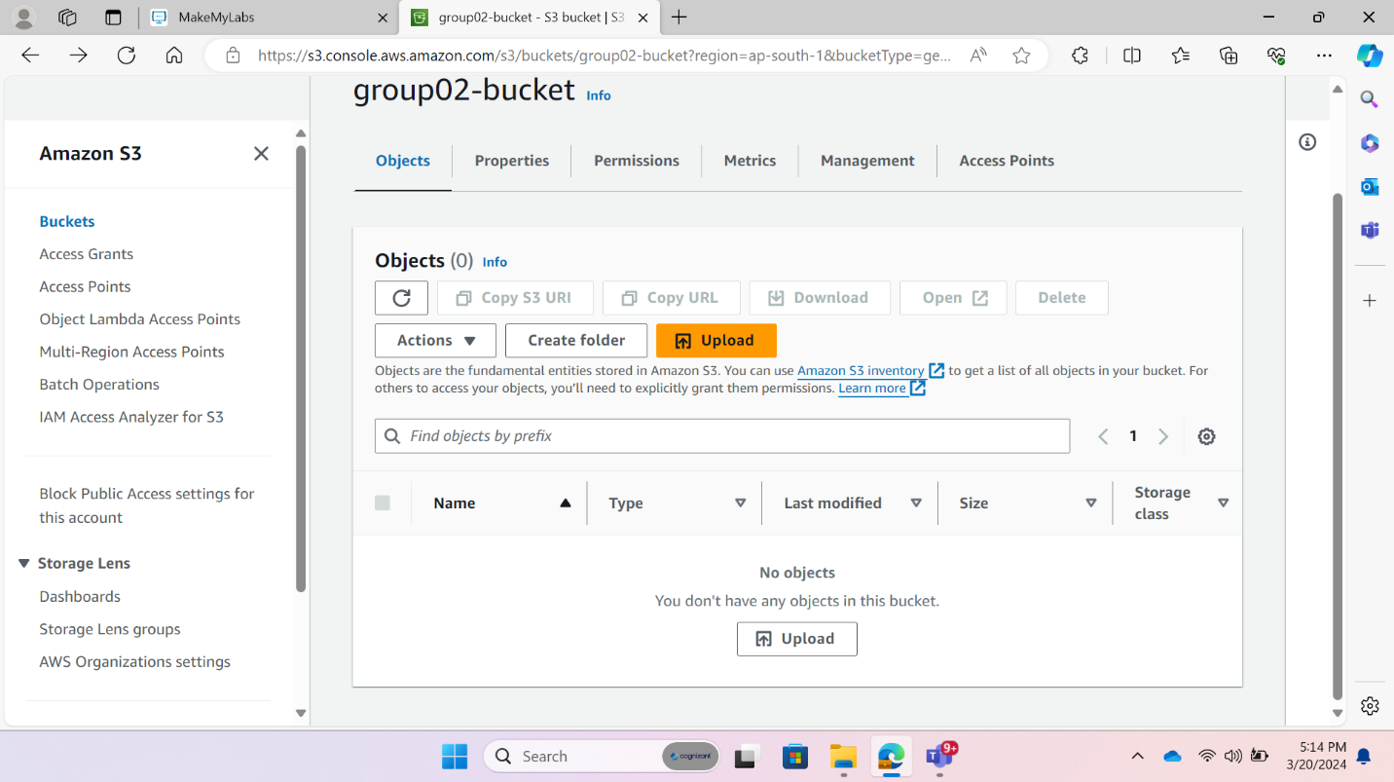So clicked on “Upload.”

Fig:17 S3 file upload1

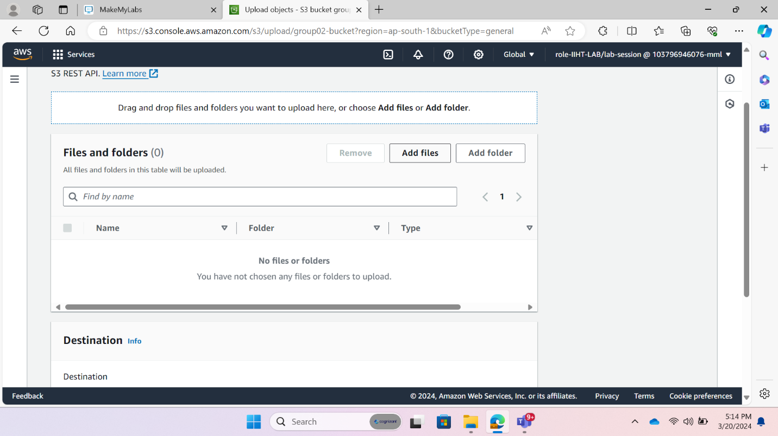Then clicked on “Add files” or “Add folder” option to upload file from local machine.

Fig:18 S3 file upload2

Then we selected our datasheet from our local machine, shown in fig 19.

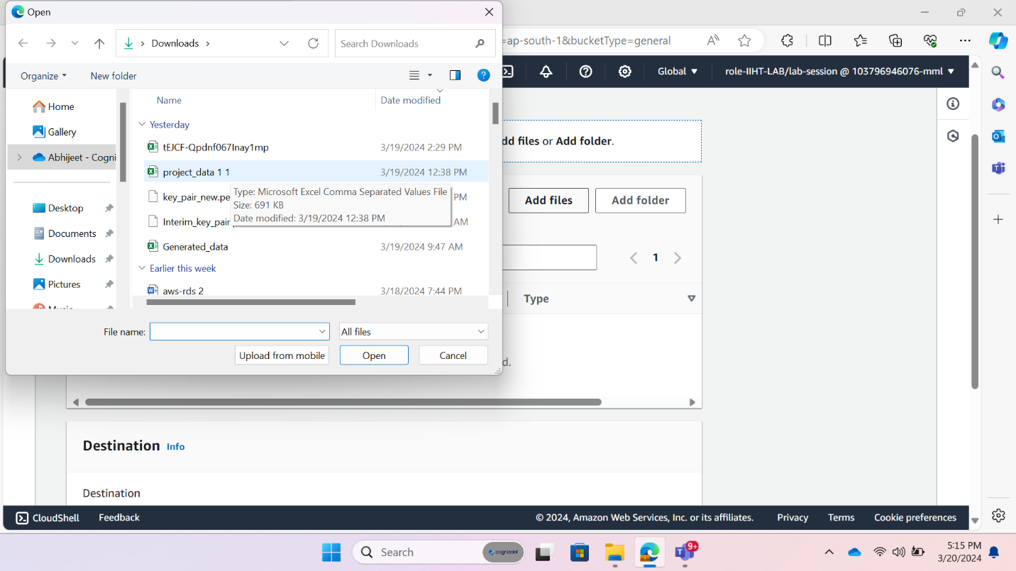

Fig:19 S3 file upload 3

At last file is uploaded in S3 bucket Shown in fig 20.

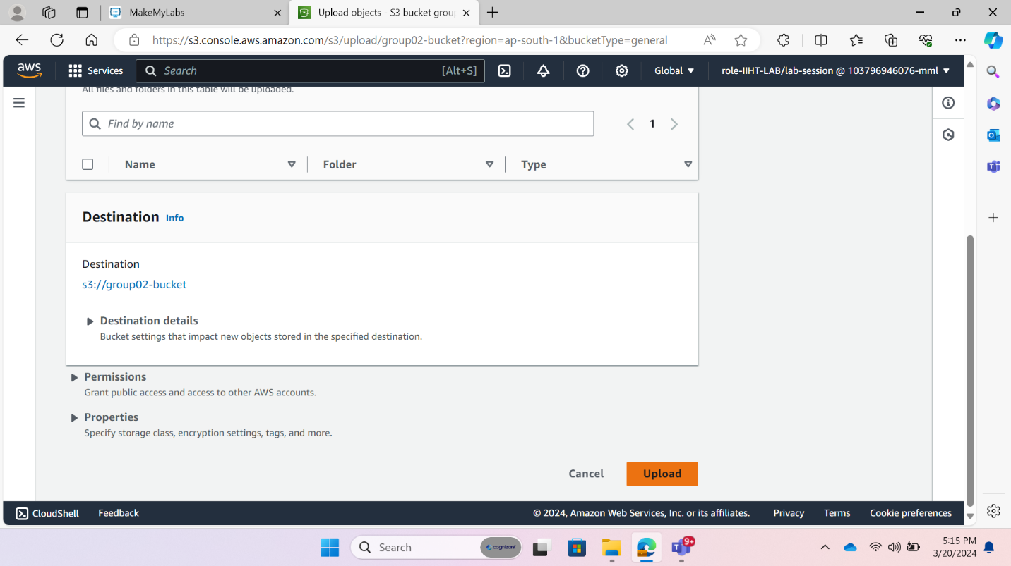

Fig:20 S3 uploaded file

**Data load S3 Bucket to Redshift Cluster**

For load data from S3 to Redshift Cluster first open Query Tool from Redshift Cluster. The interface of” Redshift query editorv2” is shown below fig 21

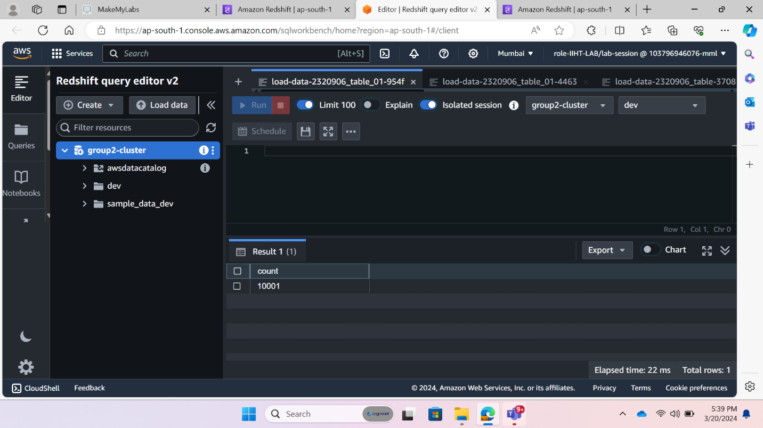

Fig:21 Redshift query editorv2

Then we upload data from “load data” option. And we Browsed data from S3 bucket that show in below figures.

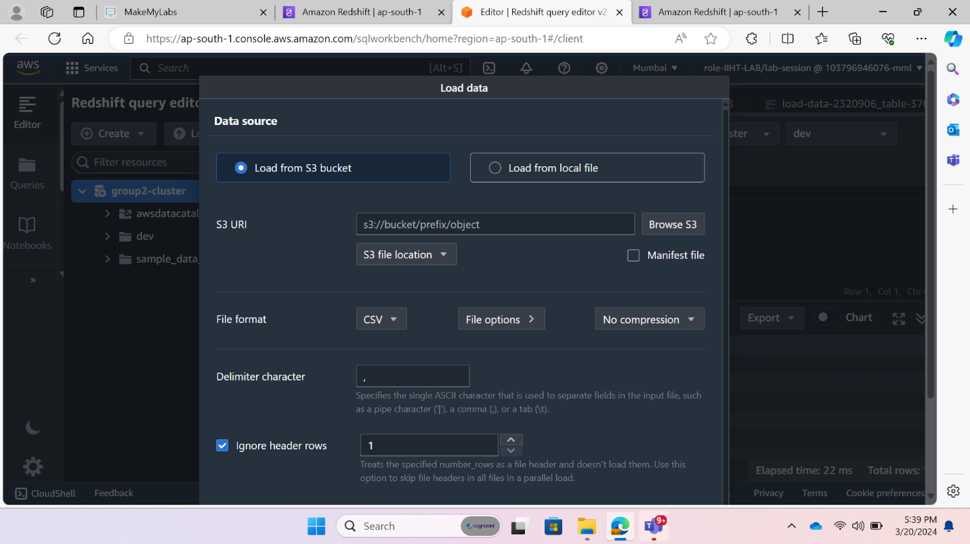

Fig:21 Redshift file upload

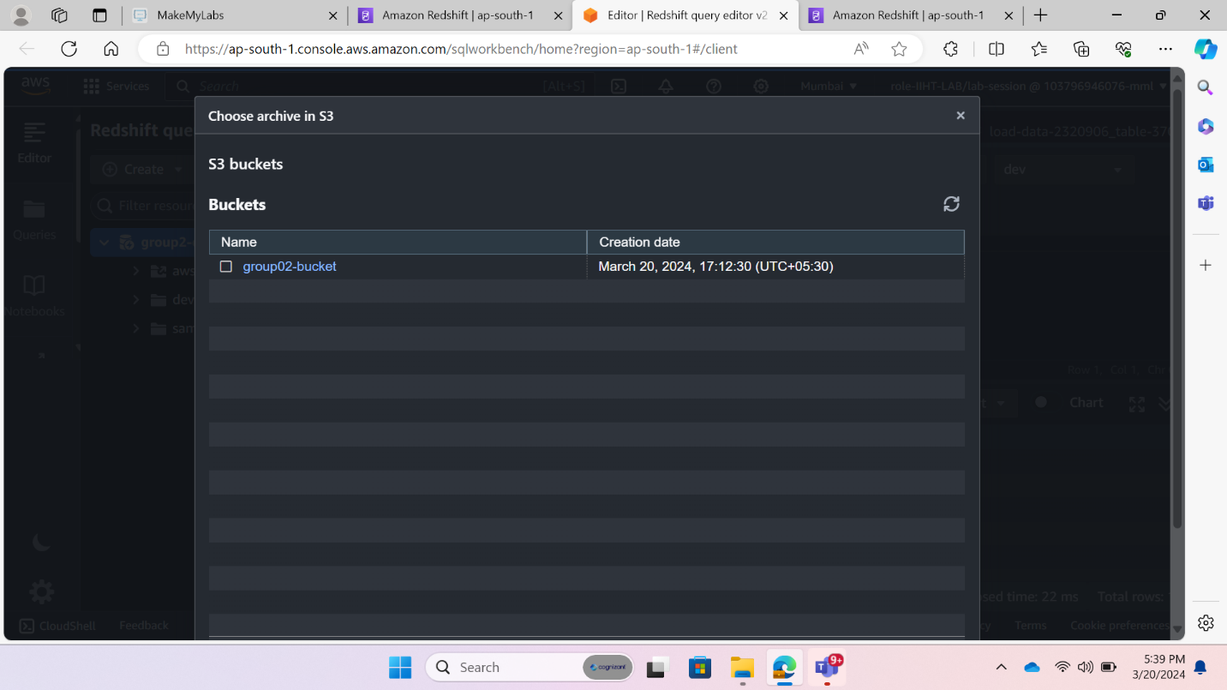

Fig:22 S3 uploaded file2

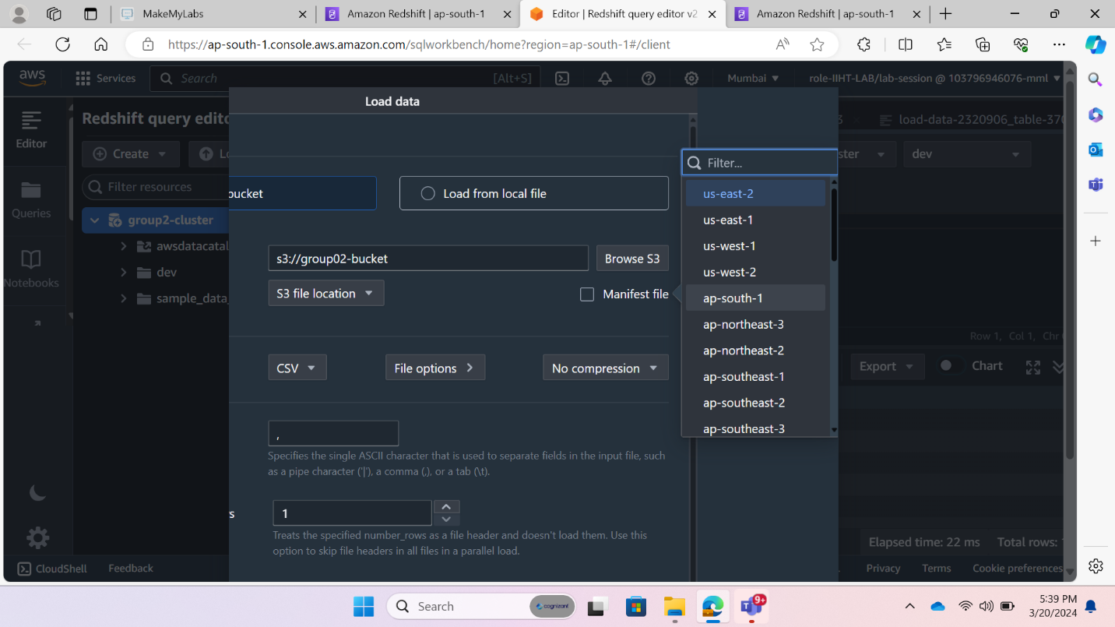

Fig:23 S3 uploaded file3

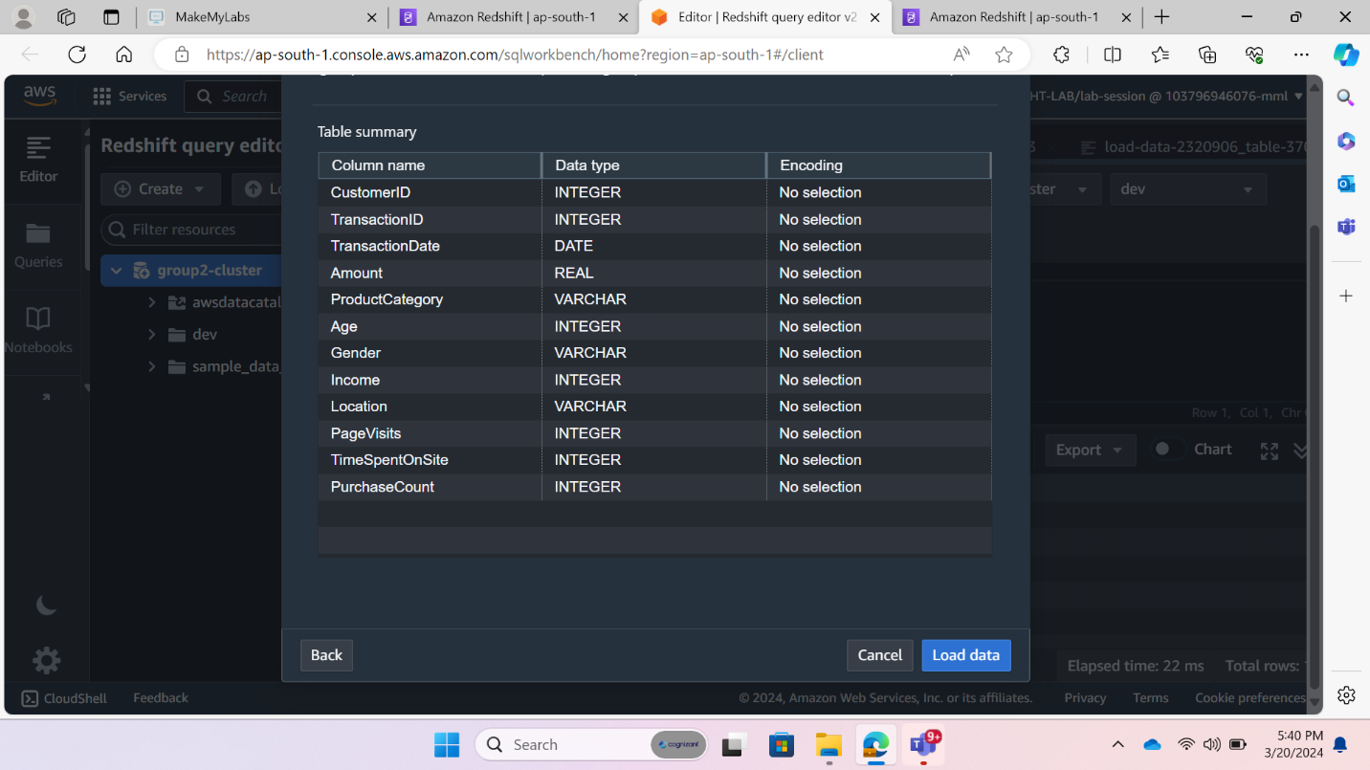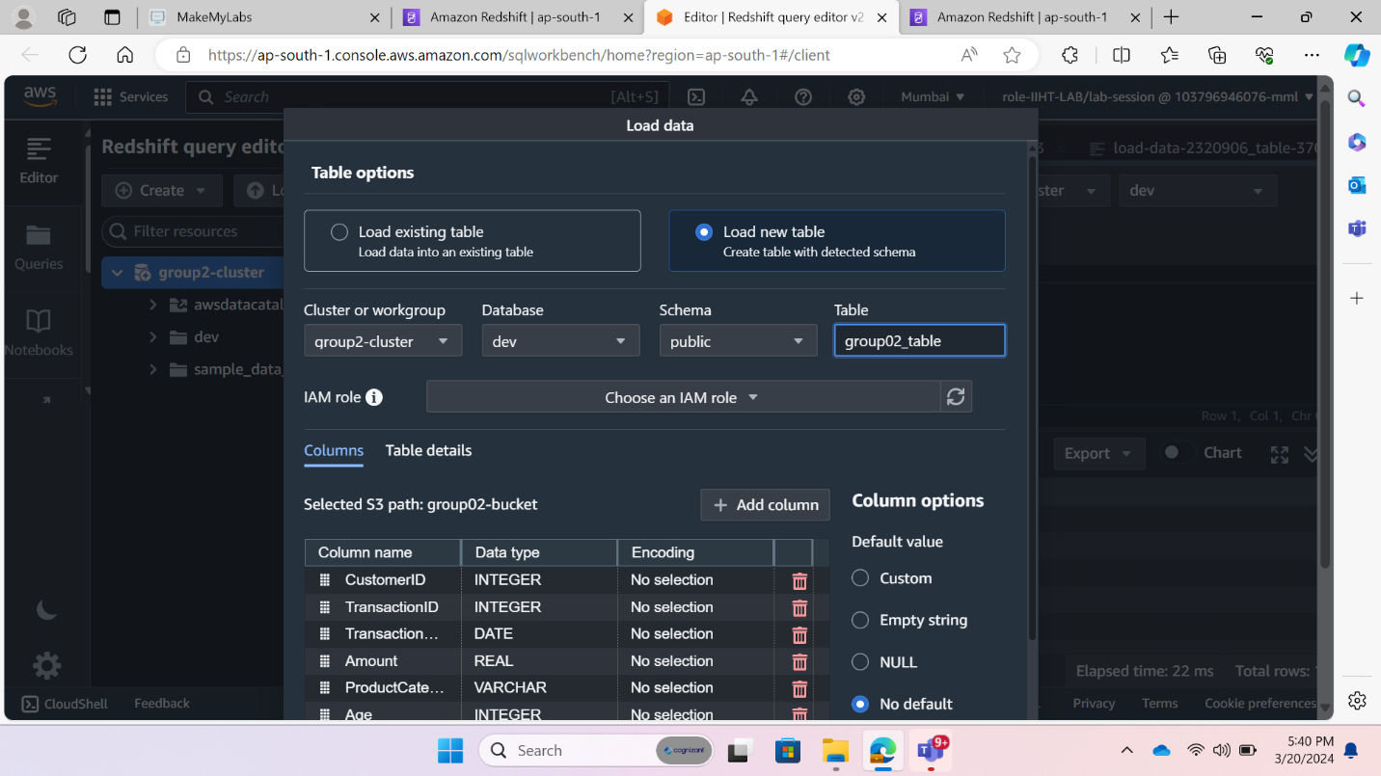

Fig:25 S3 uploaded file 5

Fig:24 S3 uploaded file4

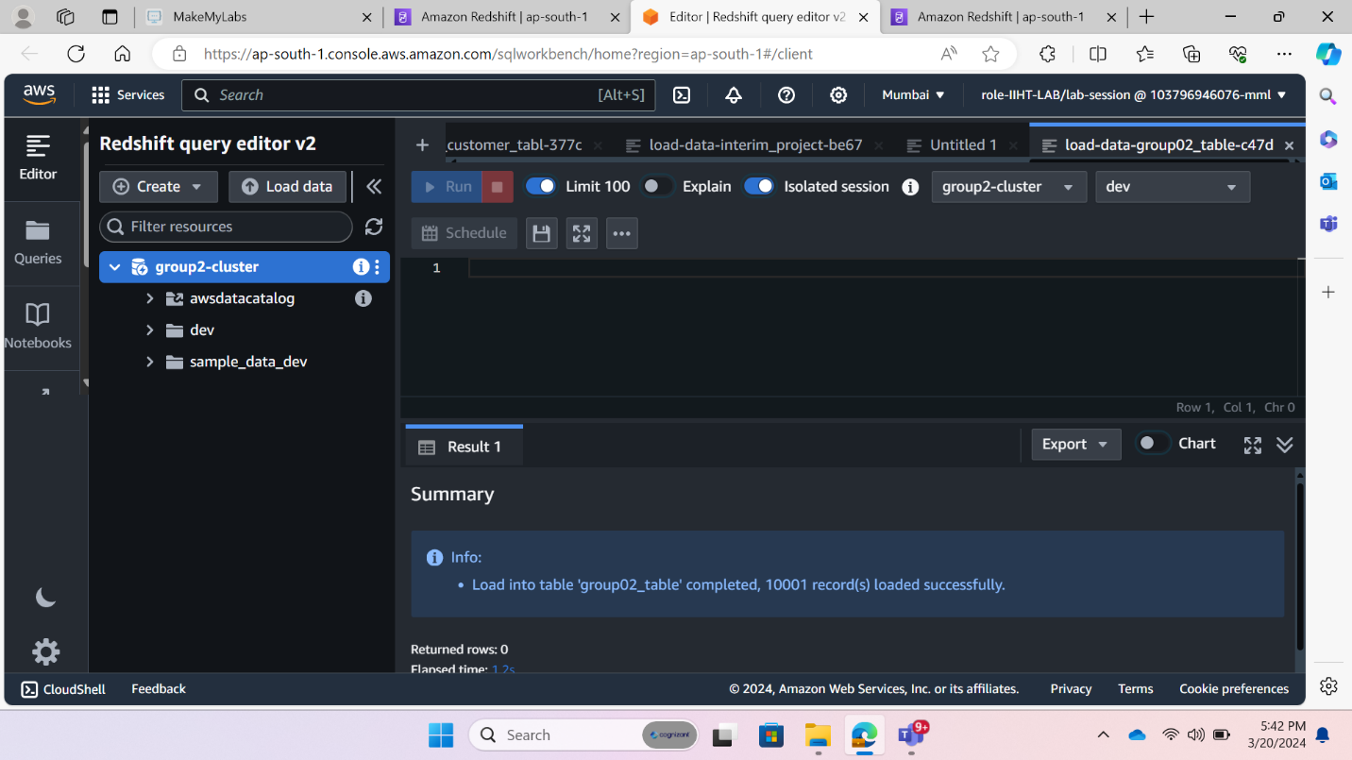

Fig:26 S3 uploaded file 6

**Requirement II: Segment customers based on purchasing behavior, demographics, or other attributes using SQL queries and analytical functions.**

**-- --purchasing behavior**

**1. Based on Total Amount**

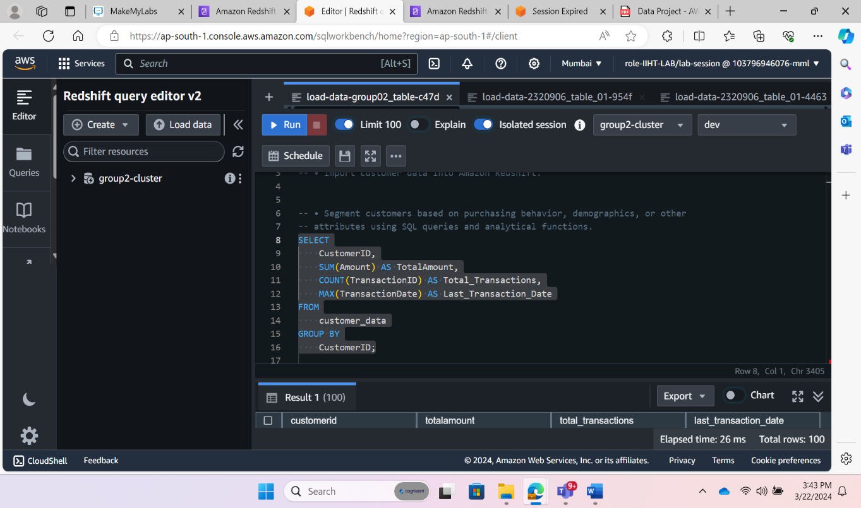

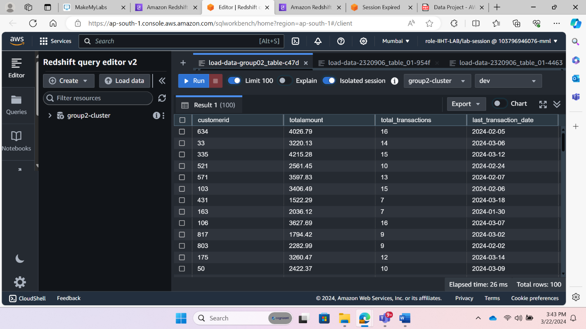

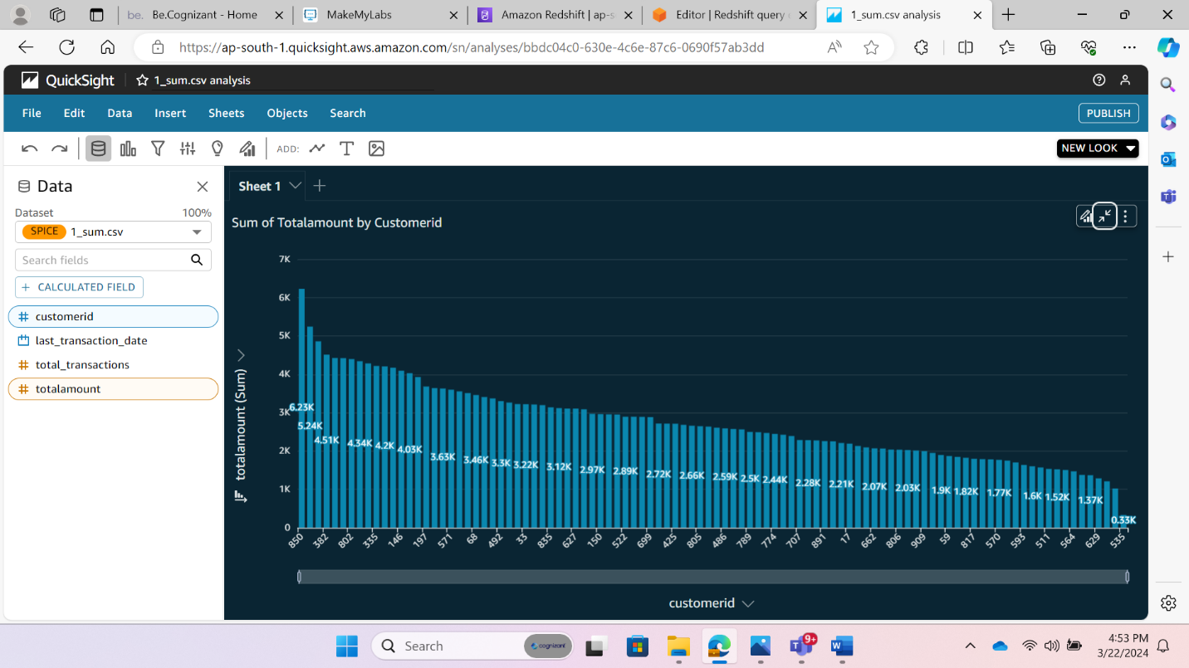

2. **purchasing behavior Based on Value**

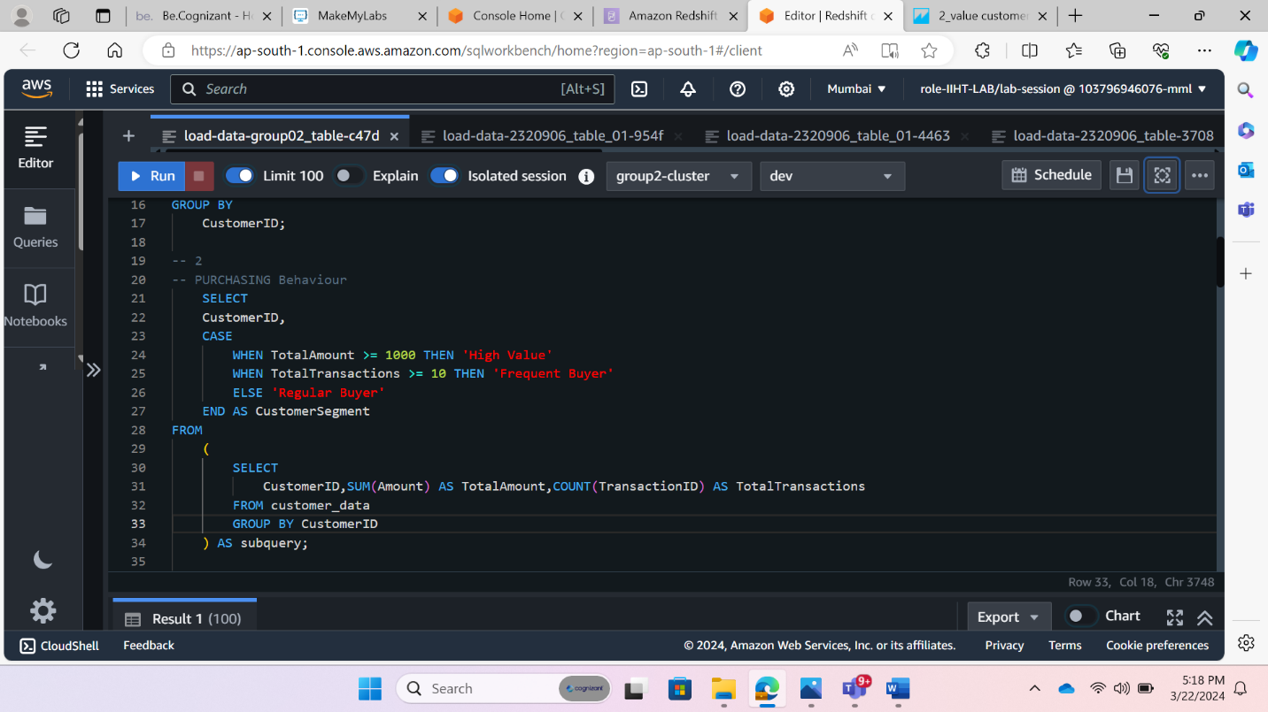

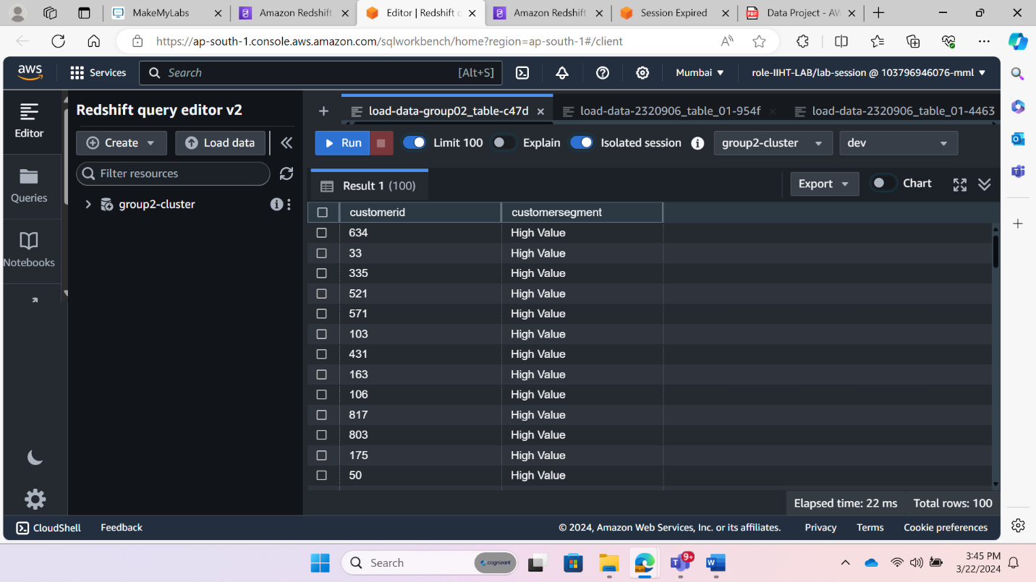

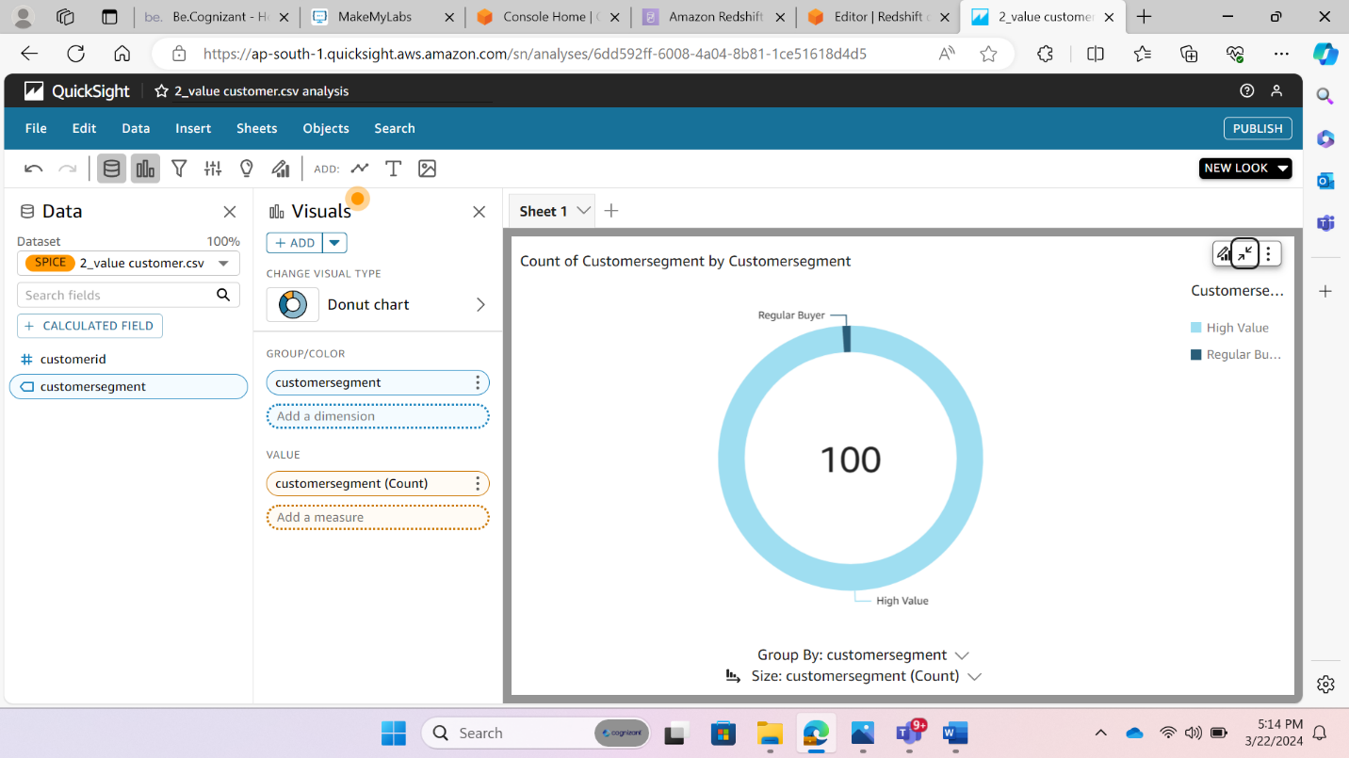

3. **purchasing behavior Based on product category**

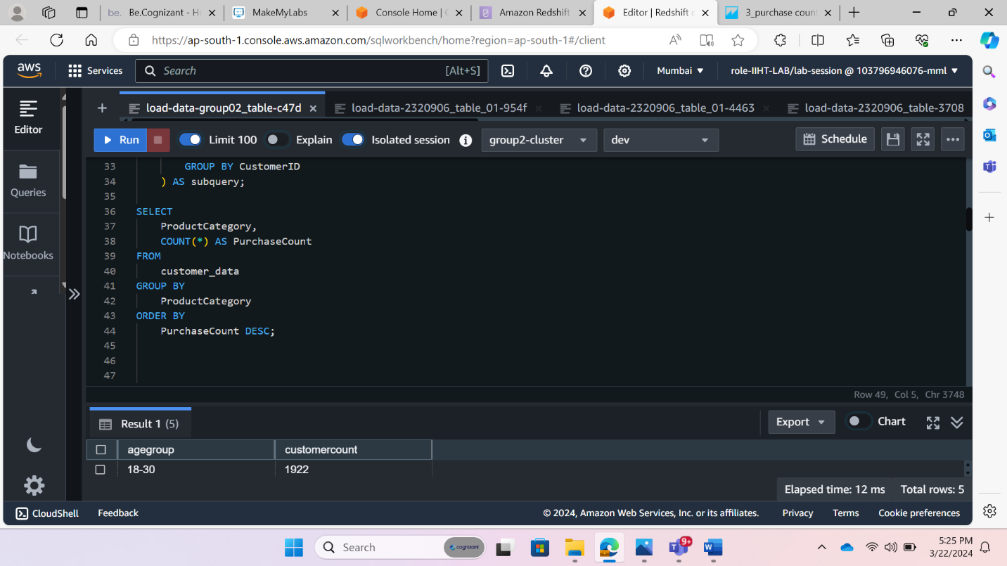

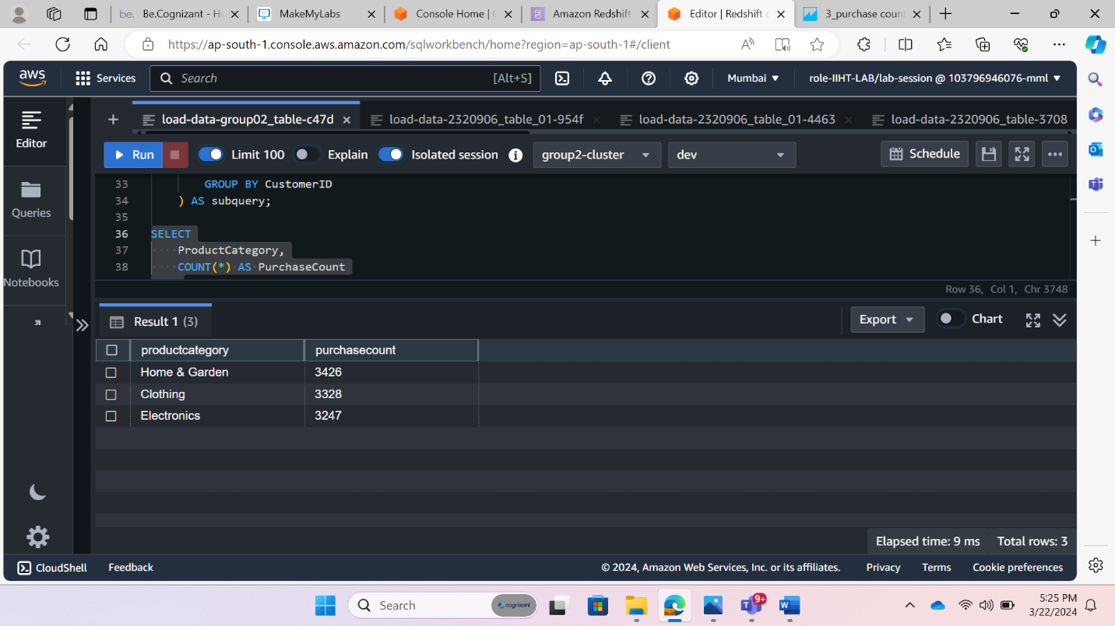

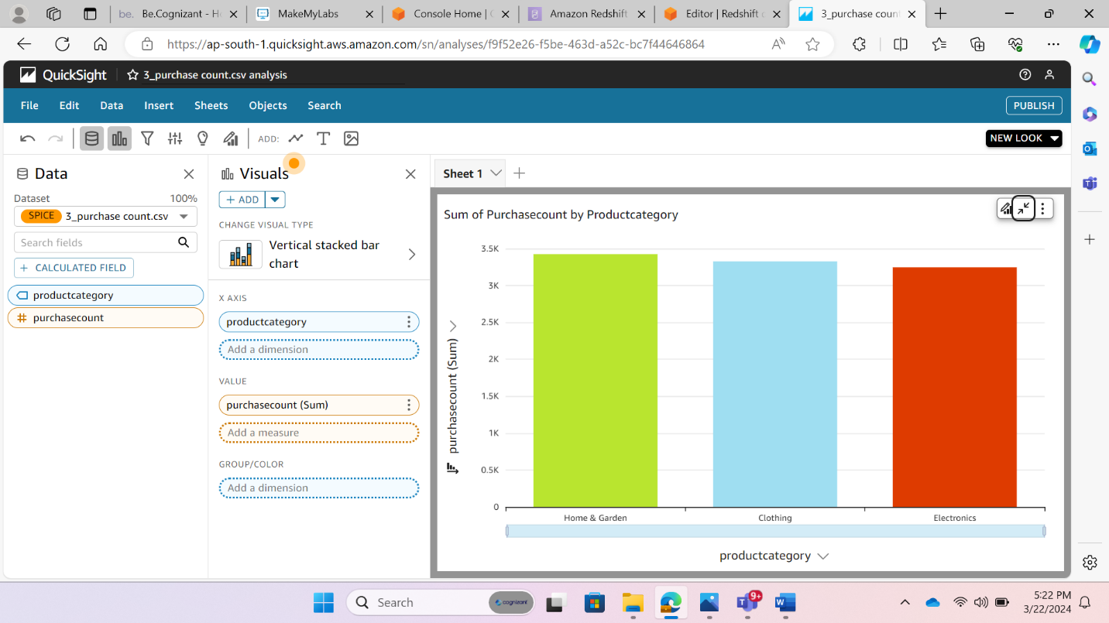

**4. Segmentation on the basis of age**

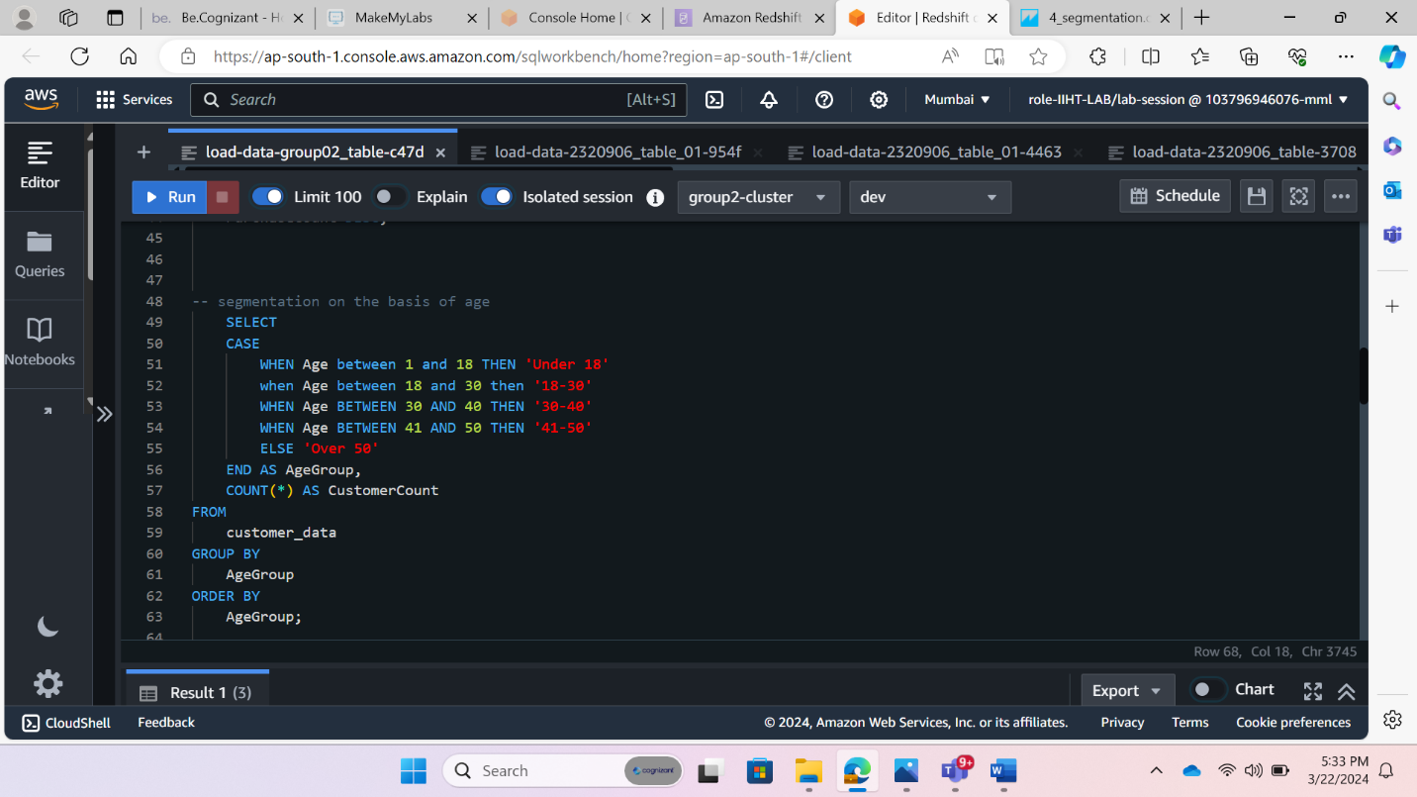

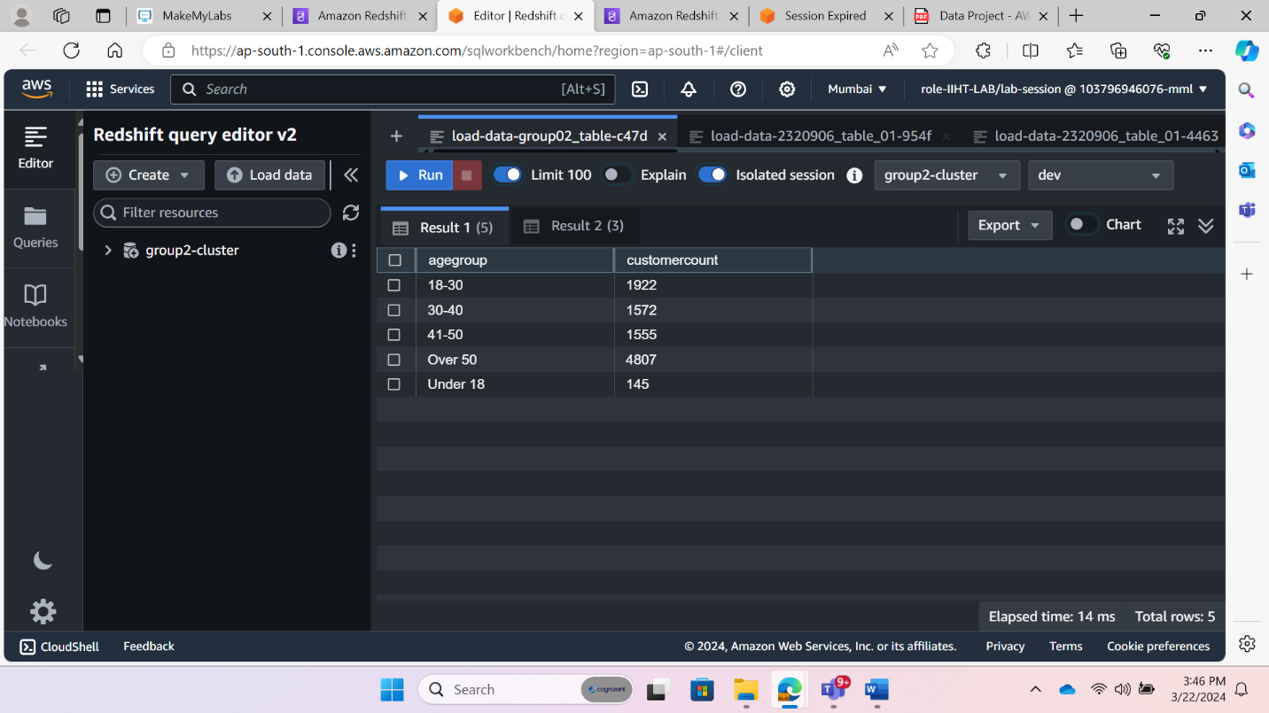

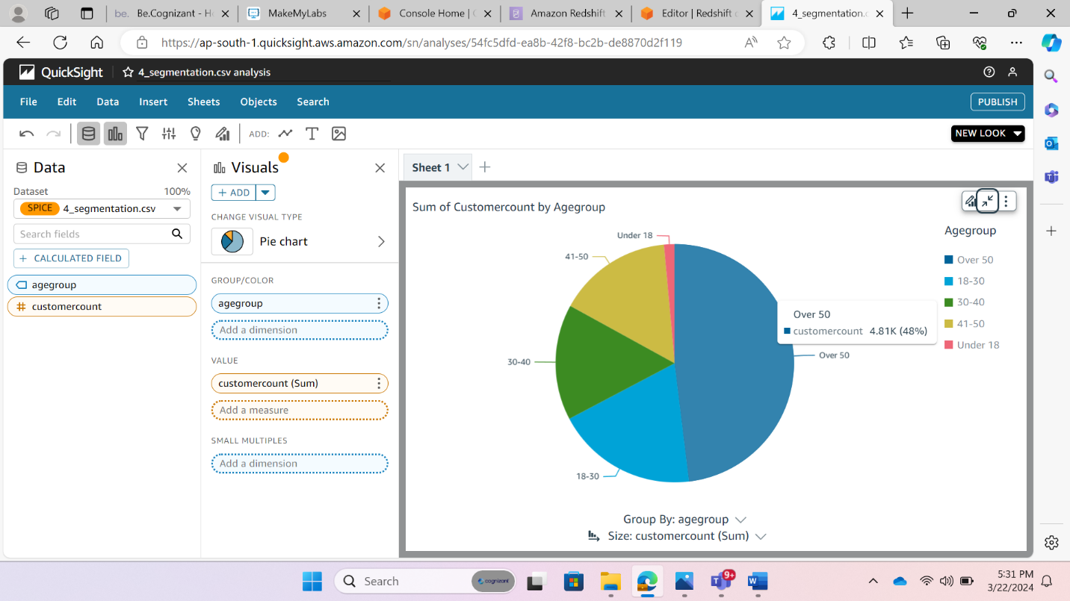

**Requirement III: Analyze each segment's buying patterns and preferences by calculating metrics such as average order value, purchase frequency, and product preferences.**

**--Total money spent locationwise**

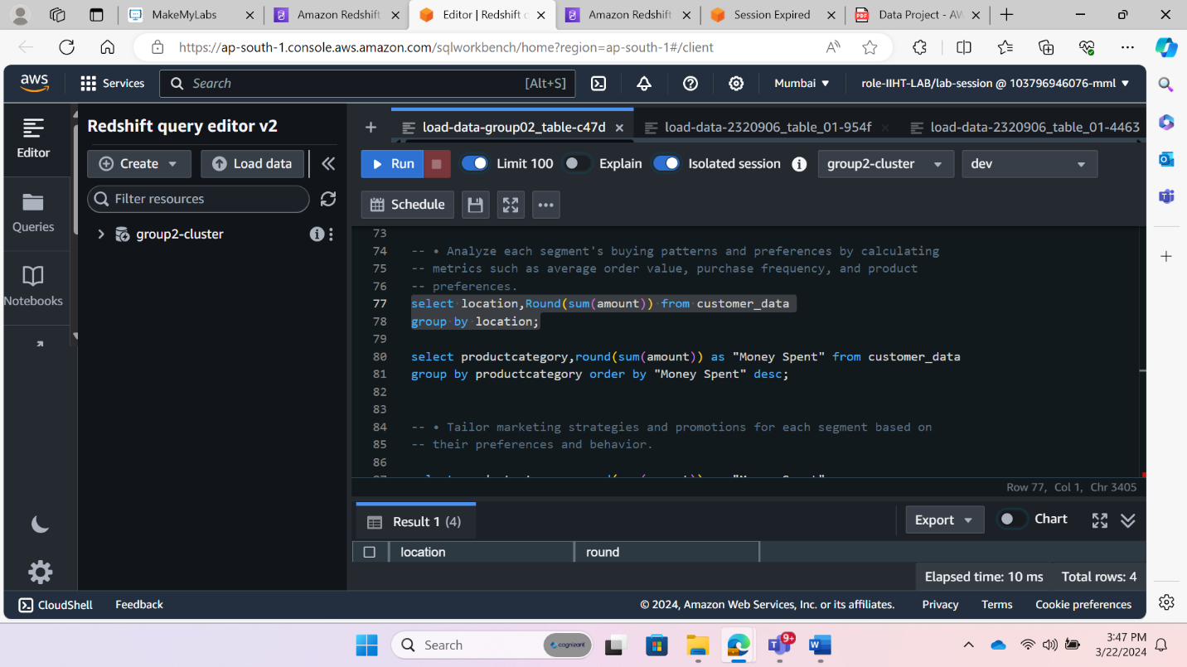

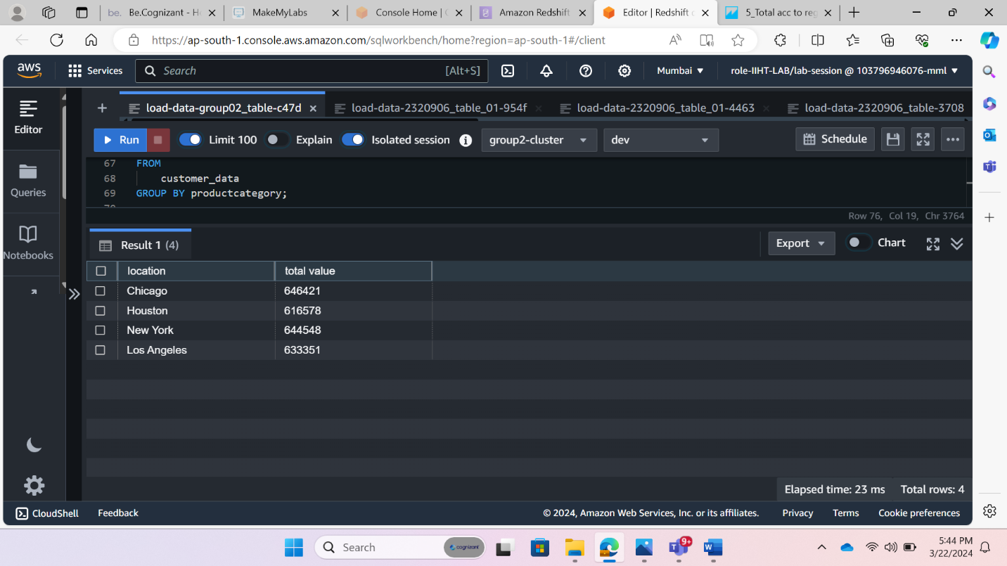

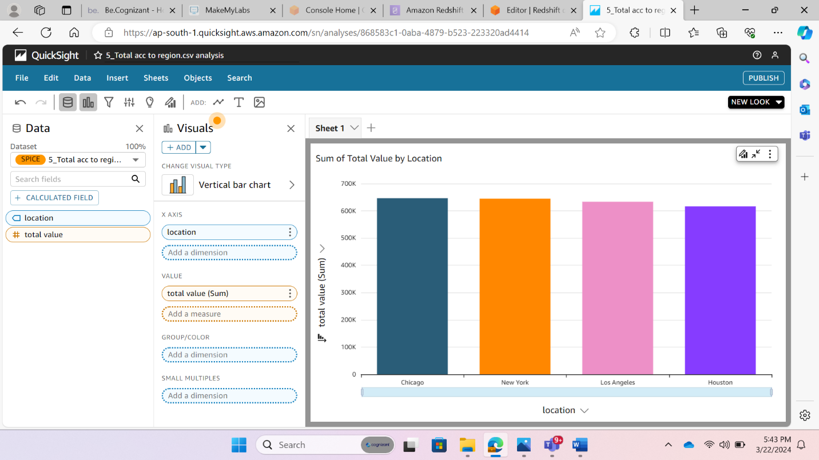

**Total Money spent according to Product category**

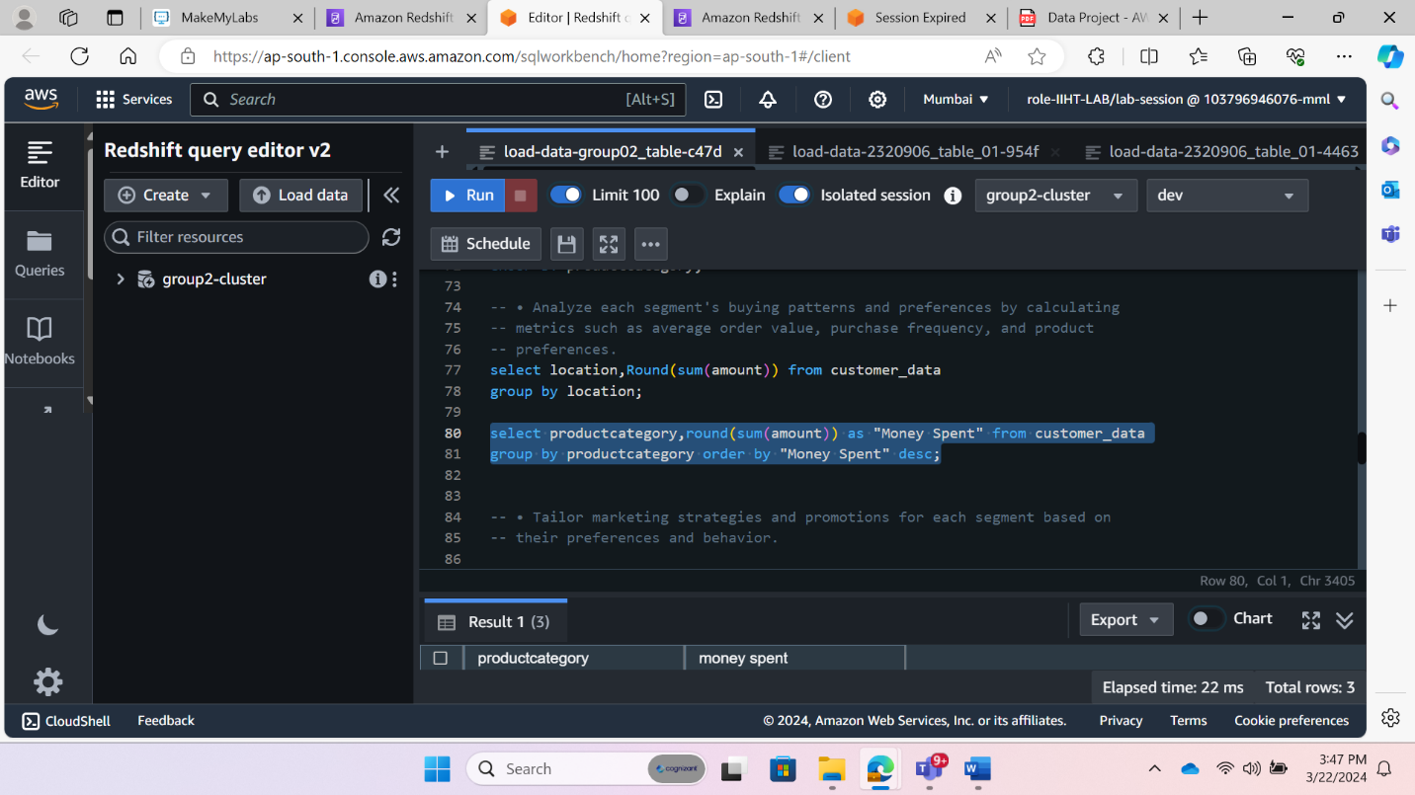

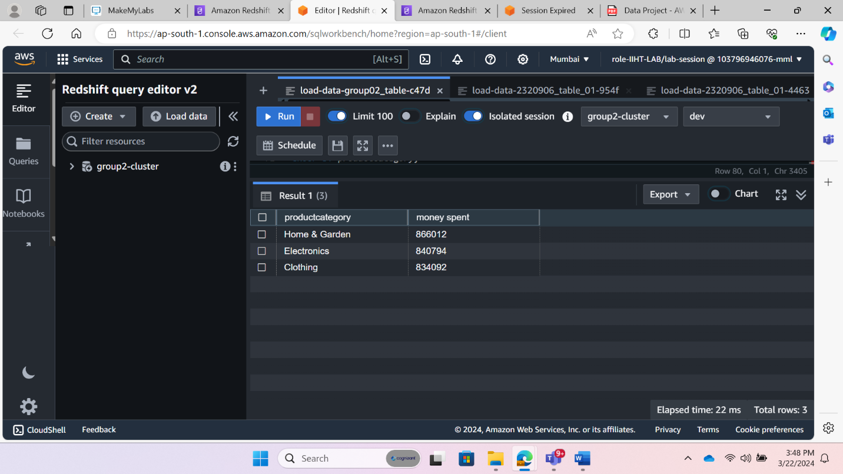

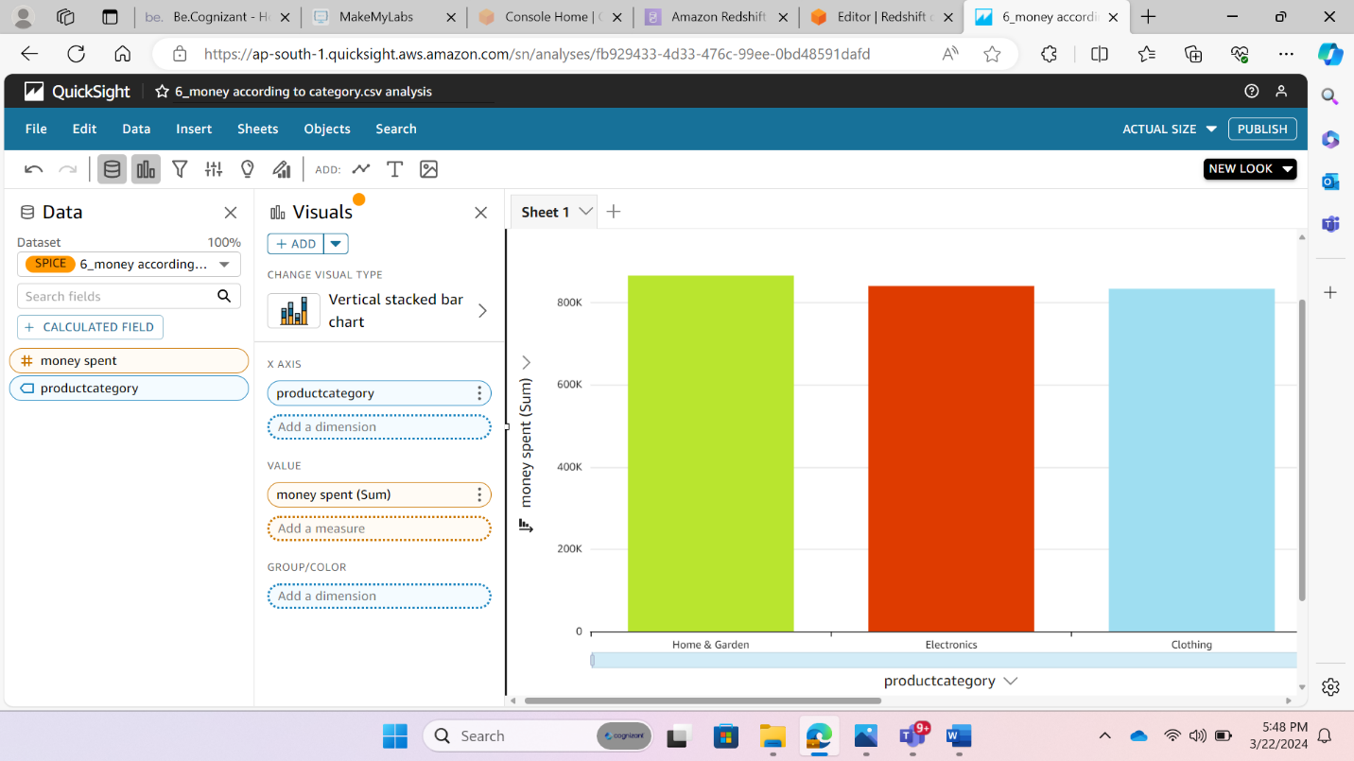

**Average money spent on each category**

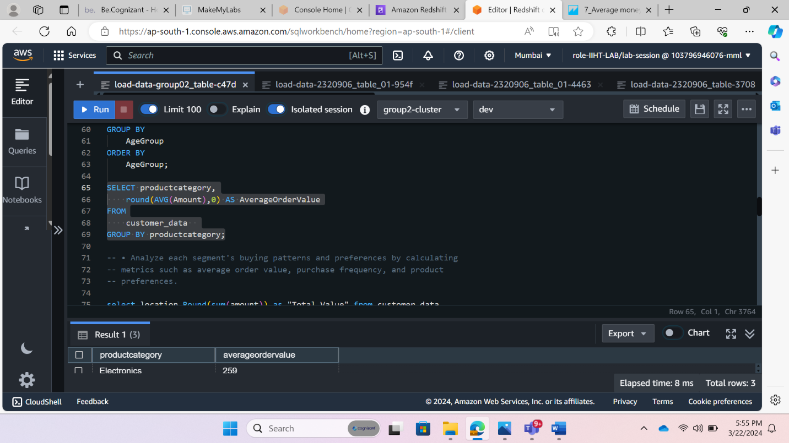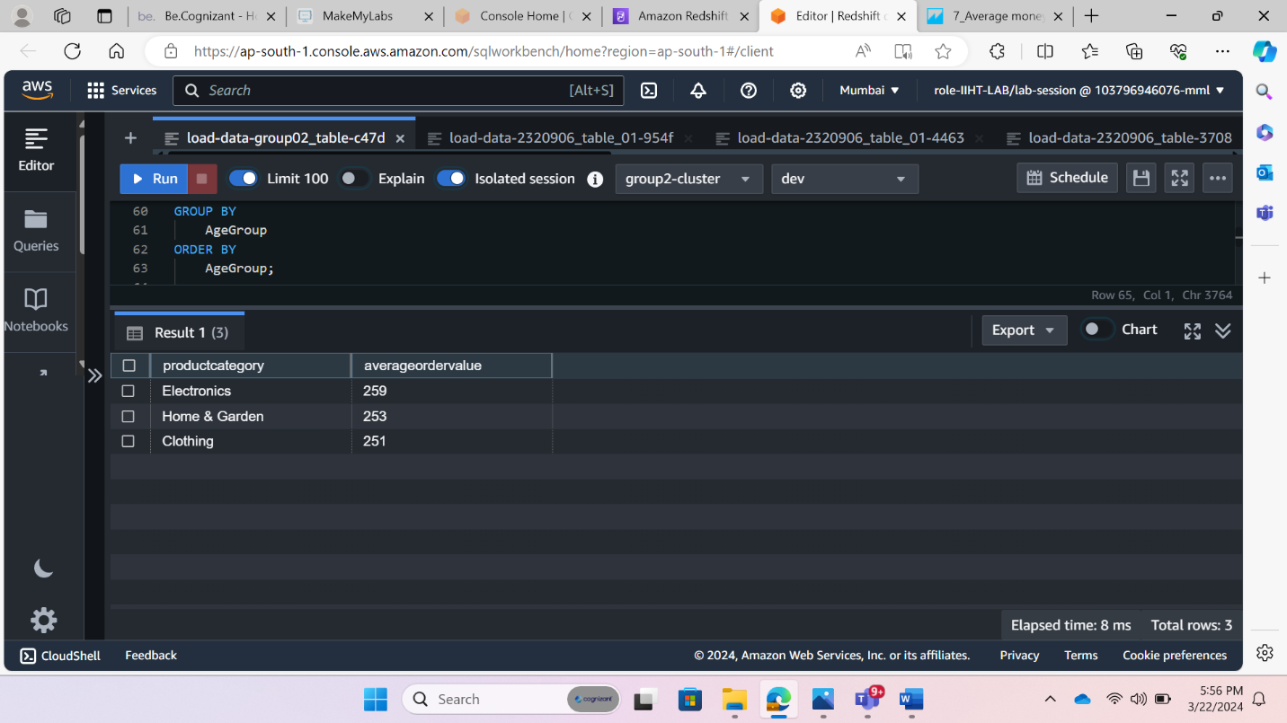

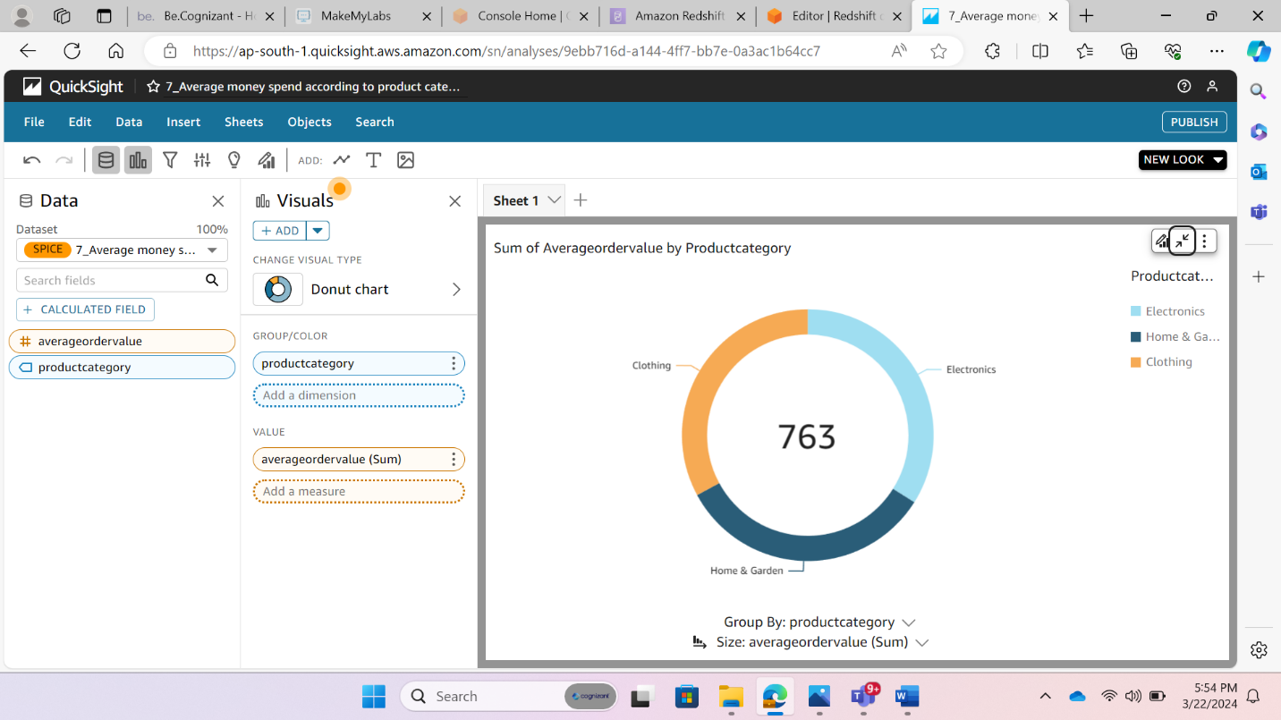

**Marketing Strategy**

1. **Promotion Needed**

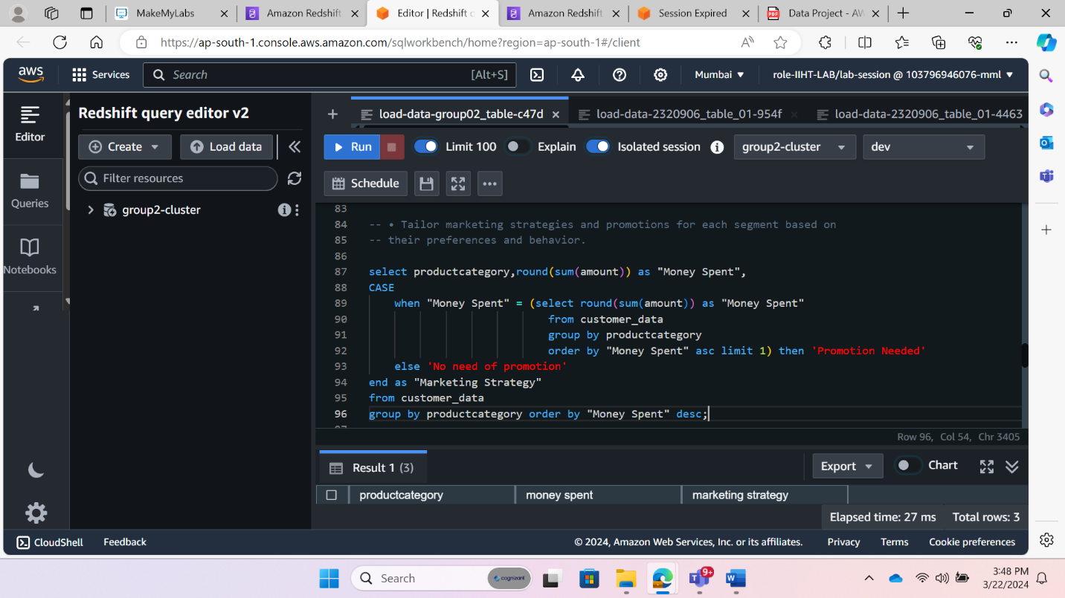

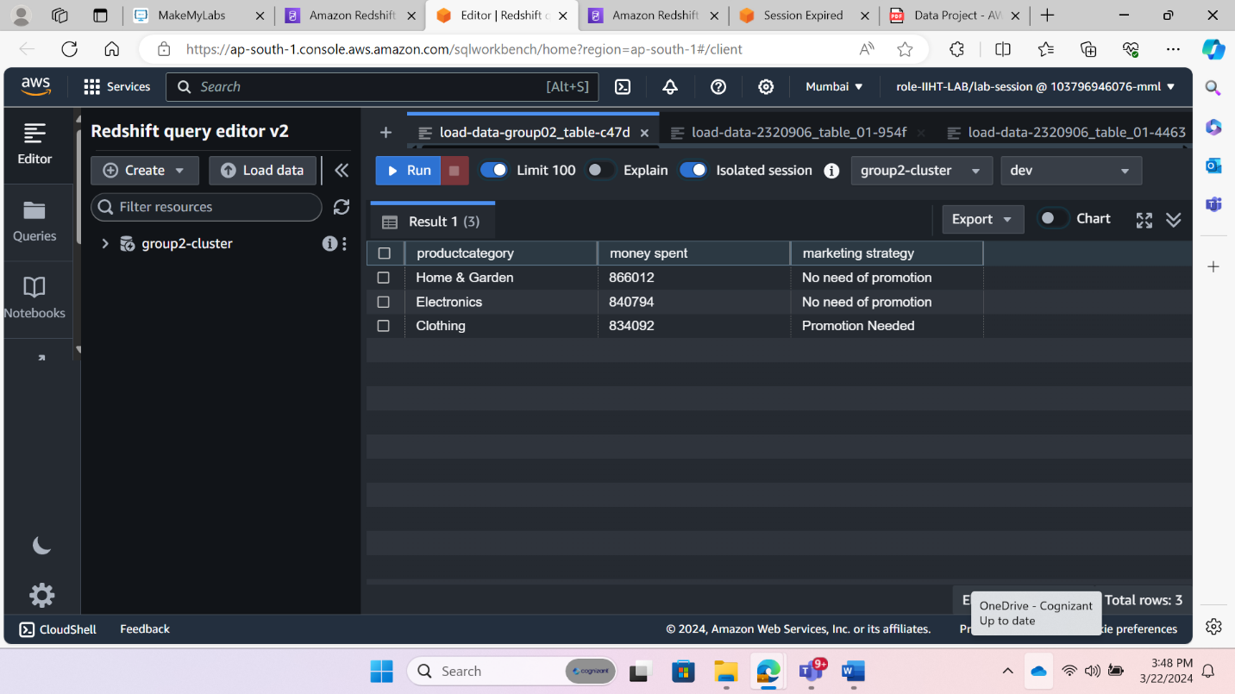

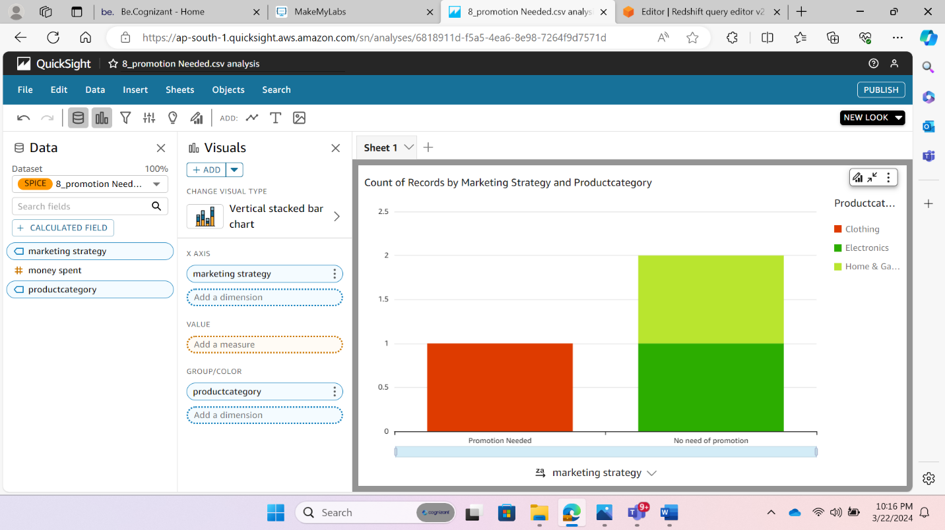

**Marketing Strategy by providing Coupons and Discounts**

